**FPT ACADEMY INTERNATIONAL**



## FPT – APTECH COMPUTER EDUCATION

**RICHFIELD CHAIR**

|  |  |  |  |
| --- | --- | --- | --- |
| **Center Name** | | FPT – Aptech – HCM2  Address: 590 Cach Mang Thang Tam, District 3, Ho Chi Minh City | |
| **Instructor** |  | Ms. Le Mong Thuy |  |
| **Class** |  | T1.2208.A0 |  |
| **Group** |  | 5 |  |
| **Group members** | | **Name** | **Student ID** |
|  |  | Nguyen Van The | Student1396965 |
|  |  | Nguyen Van Quang | Student1387818 |
|  |  | Nguyen Huu Hao | Student1409672 |
| **Duration** | Start date | 14th November 2022 |  |
| |  |  | | --- | --- | | End date | 14th August 2021 | |  |  |

**This is to certify that**

**Mr.:**

Nguyen Van The

Nguyen Van Quang

Nguyen Huu Hao

**has successfully designed & developed**

eProject: Richfield chair

**Submitted by:**

Nguyen Van The

**Date of issue:**

**Authorized Signature:**

**TABLE OF CONTENTS**

****FPT – APTECH COMPUTER EDUCATION 1****

****TABLE OF CONTENTS**** ****2****

****ACKNOWLEGMENT**** ****3****

****SYNOSIS**** ****3****

****PROBLEM DEFINITION**** ****3****

****CUSTOMER'S REQUIREMENTS SPECIFICATIONS (CRS) 4****

****Business/Project Objective**** ****4****

****Hardware/ Software Requirements**** ****5****

****SCOPE OF THE WORK (IN BRIEF) 6****

****Architecture and design of the system 7****

****Diagram of the website 8****

****TASK SHEET REVIEW 1 9****

****SITE MAP 10****

****MOCK OF THE WEBSITE 1********1****

***1. Homepage 1******1***

***2. Product 1******2***

***3. Compare 1******3***

***4. About Us 1******4***

***5. Contact US 1******5***

****TASK SHEET REVIEW 2 16****

WEBSITE DESCRIPTION ****1********7****

RESPONSIVE****28****

[****JAVASCRIPT DESCRIPTION****](#Javascript) ****30****

****TASK SHEET REVIEW 3**** ****47****

# ACKNOWLEGMENT

Richfield Chairs is an organization selling Chairs. They produce various chairs of

different types suiting every requirement and into various sizes, starting from kids to

office to home and etc.

# SYNOSIS

# The goal of the eProject is that we need to create a website that meets all the requirements of the client, Richfield chair. Richfield chair is specializing in the supply of various chairproducts. They always satisfy customers with professional staff with many years of experience. The main goal of this website is to reach customers who need the best quality chair products for their home or company. In addition, the products have discounts and promotions for customers, especially the company also supports the direct installation of their products. Customer satisfaction is always the top goal of Richfield chair.

# PROBLEM DEFINITION

The Web site is to be created based on the following requirements.

1) The Home Page should be created making use of Sections with a suitable logo, the header section can be added which will show images chairs.

2) The site must contain the links to navigate through any category for the information.

3) The site should display a menu which will contain the options for brief introduction about the various furniture’s available, location of the shop and any other information if required.

4) The information should be categorized according to the brand names of the chairs like if a User wants to see only “LEO” chairs or any other companies chairs then he/she can click on a Link/button/menu etc and can see only that Brand chairs.

5) When a user selects any particular brand, a list of chairs for that brand will be displayed

6) A brief summary of features of the chairs should be displayed on the Web Page along with the picture but detailed Features should be stored in Individual Word documents which can be downloaded or viewed by the User who wishes to see the same.

7) The user should also be able to compare the various chairs of different as well as similar brands.

8) There should be a “Contact Us” page which will have the Address of the Company which should be displayed using GeoLocation API (eg. GoogleMaps) and the email address which when clicked will invoke the local mail client from where they can send an email).

# CUSTOMER'S REQUIREMENTS SPECIFICATIONS (CRS)

**Client: Richfield chair**

### Business/Project Objective:

Richfield Chairs is an organization selling Chairs. They produce various chairs of different types suiting every requirement and into various sizes, starting from kids to office to home and etc. You are supposed to create a website for them with the below mentioned requirement specifications. The website is to be developed for the Windows Platform using HTML5, JavaScript and Geolocation. The site should work well in all leading browsers including Chrome, IE, Firefox etc.

**Input to the system:**

- Searching products based on OFFICE CHAIR, SOFA, KID'S CHAIR.

- Feedback about the quality of products

**Output from the system:**

- Display results for each type of product according to the search content.

– Display product information by price...

– Display the special information of the product.

- Display products of the same type, same brand, other related products.

- Display a button so that customers can download the product's catalog

- Product comparison results

- Customers can also download the price list of products on the website

- Site should be able to provide brief introduction/history about the shop under About Us page.

- The location of the shop under Contact-Us page.

- Displays FAQ and allows users to email directly to the company

**Process**:

* + - * Validate data input from users.
      * Compare for 3 products at the same time

**Expected delivery date:** 16-December-2022.

**List of deliverables:**

- Document Word, PDF.

- User Guide.

- Source code.

### Hardware/ Software Requirements:

* **For developer**

**Hardware**

* + Intel Pentium 4 processor or higher
  + 01 Gigabytes of RAM or higher

**Software**

* + Windows 7 OS or higher
  + Adobe Dreamweaver
  + Web browsers such as IE, Chrome or Firefox are supporting HTML5, CSS3 and Javascript.
* **For web users**

**Hardware**

* + Intel Pentium 4 processor or higher
  + 512 Megabytes of RAM or higher

**Software**

* + Windows XP OS or higher
  + Web browsers such as IE, Chrome or Firefox are supporting HTML5, CSS3 and Javascript.

# SCOPE OF THE WORK (IN BRIEF)

After a long and detailed discussion, our group has decided to create a website contain the following webpages:

***1.Homepage***: introduce Richfield Chairs

***2.Product***: Displays all available products based on the Category category (Office chair, Sofa, and Kid's chair).the above categories, products can be filtered by name .

***3.Compare*** : Compare types of chairs, price, product quality

***4.About Us:*** Display the information of the company, clients’ review and about us.

5.***Contact Us:*** Display the address of the company, Map and allow customers to request any information they want to Richfield Chairs

# ARCHITECTURE AND DESIGN OF THE SYSTEM

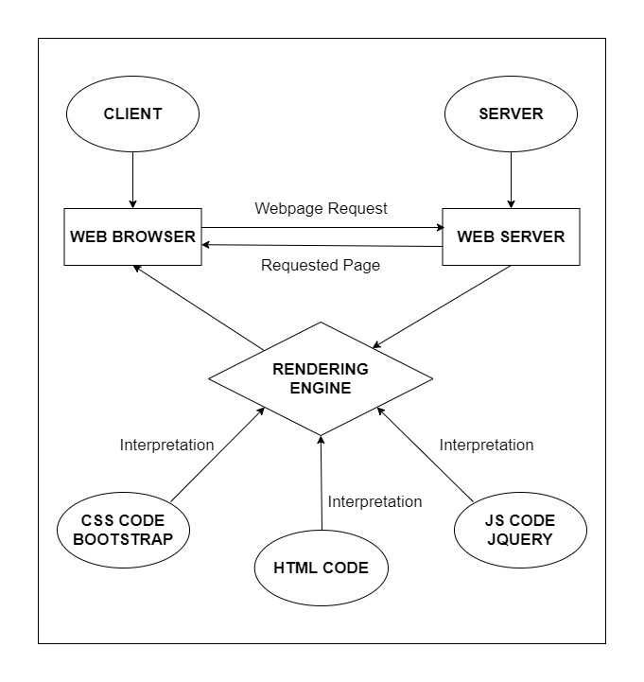

# DIAGRAM OF THE WEBSITE

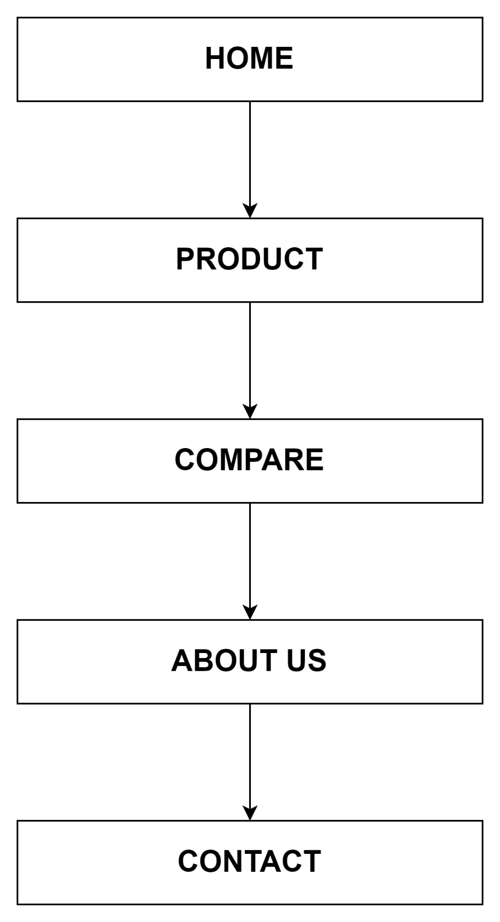



# TASK SHEET REVIEW 1

|  |  |  |  |  |  |  |  |
| --- | --- | --- | --- | --- | --- | --- | --- |
| **Project Ref. No.:**  **eP/Advertisement Portal Management**  **System/01** | | **Project Title:** | **Activity Plan Prepared By:** | **Date of Preparation of Activity Plan:** | | | |
| **Sr.**  **No.** | **Task** | **Actual**  **Start**  **Date** | **Actual Days** | **Team**  **Mate Names** | **Status** |
| 1 | Problem Statement | RICHFIELD  CHAIR | The | 14-Nov-22 | 1 | The | Completed |
| 2 | Analysis of Richfield chair requirements about the website | 14-Nov-22 | 1 | The | Completed |
| 3 | The scope of the work (in brief) | 14-Nov-22 | 1 | Quang | Completed |
| 4 | Architecture and design of the system | 14-Nov-22 | 1 | Quang | Completed |
| 5 | Diagram of the website | 14-Nov-22 | 1 | Hao | Completed |
| 6 | Task Sheet | 14-Nov-22 | 1 | Hao | Completed |

|  |  |
| --- | --- |
| **Date:** | |
| Signature of Instructor:  **Ms. Le Mong Thuy** | Signature of Team Leader:  **Nguyen Van The** |

# SITE MAP

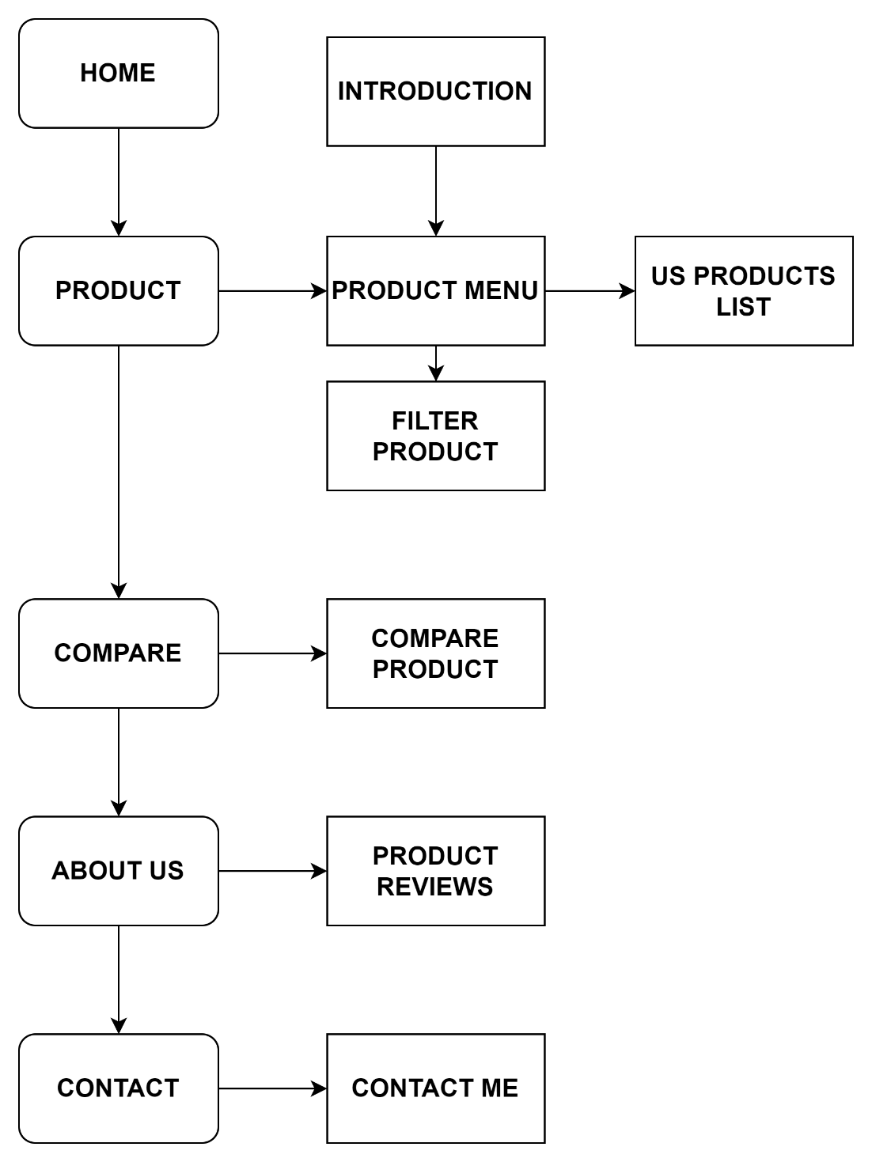

# MOCK OF THE WEB SITE

1. **Homepage**

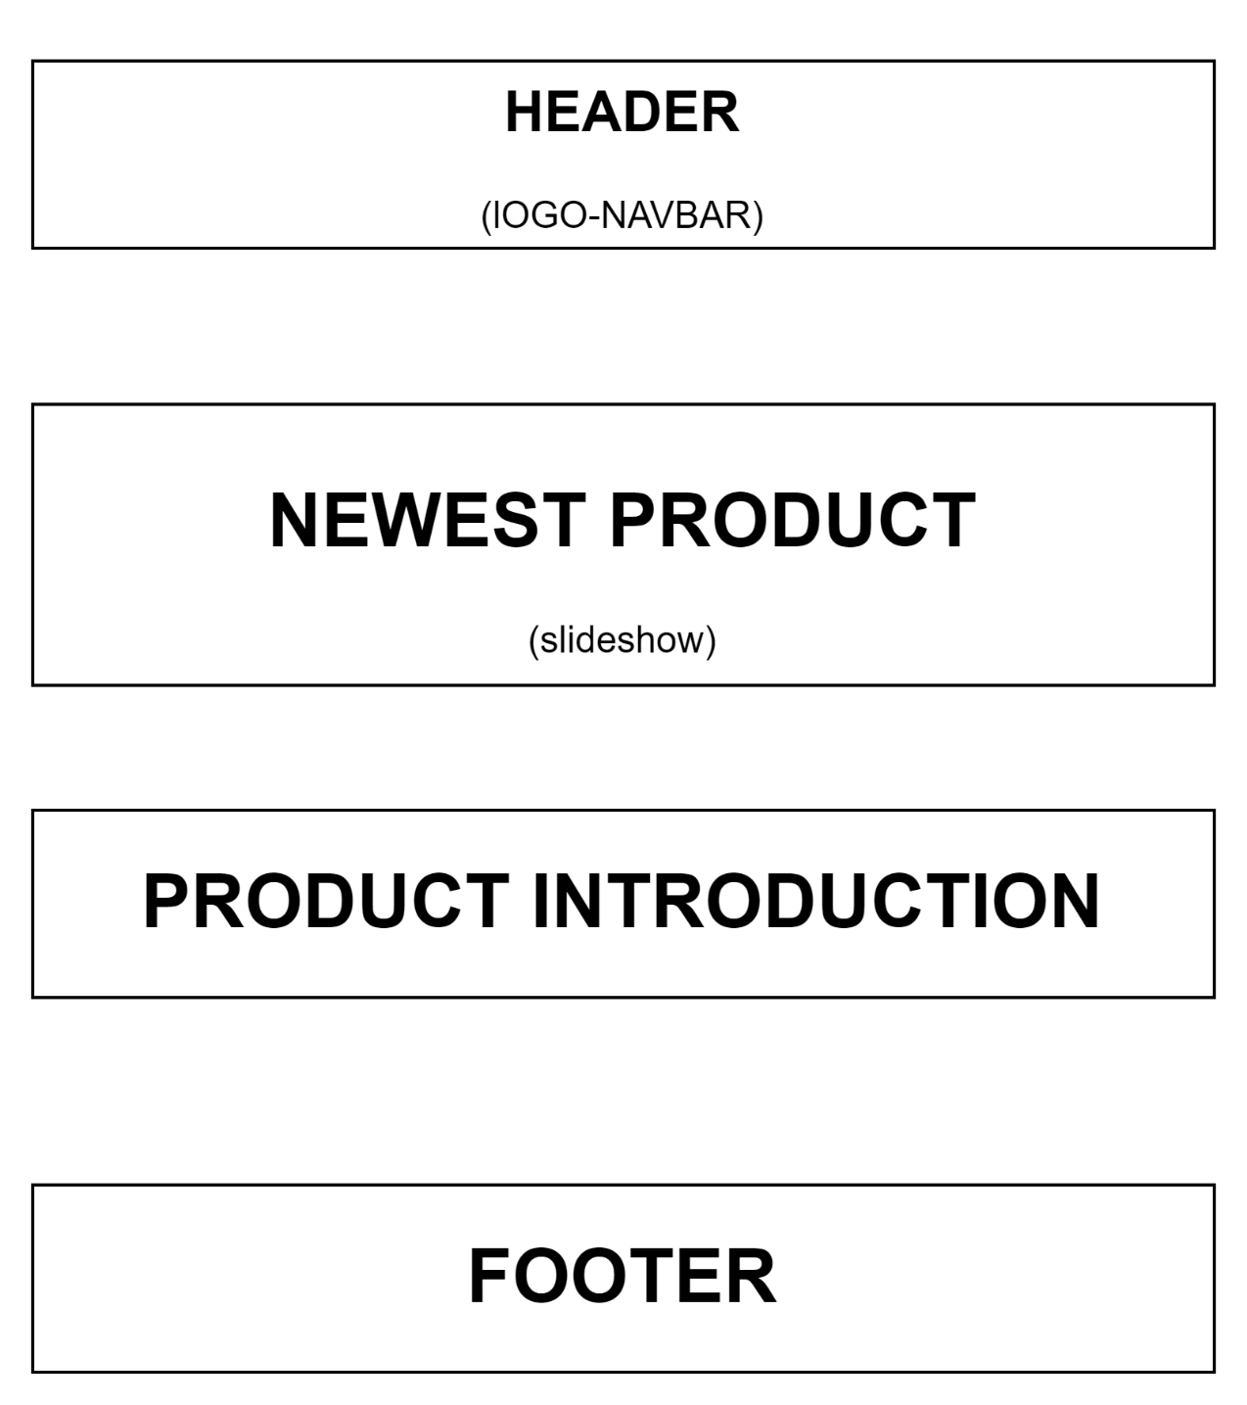

1. **Product**

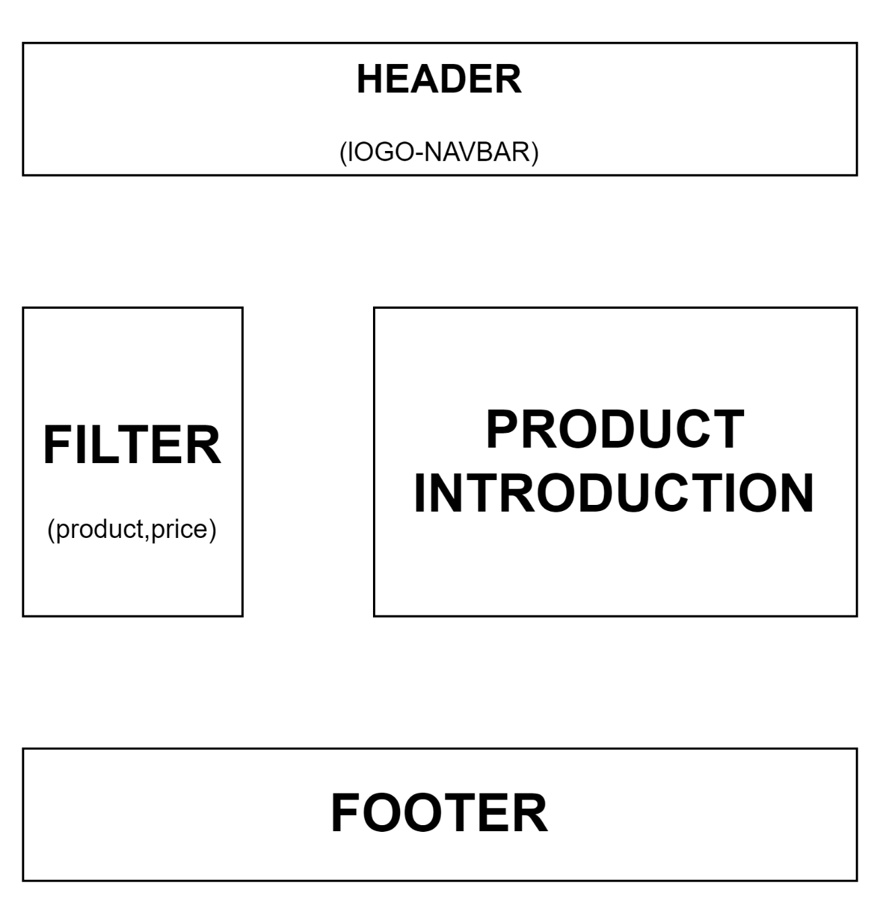

**3.Compare**

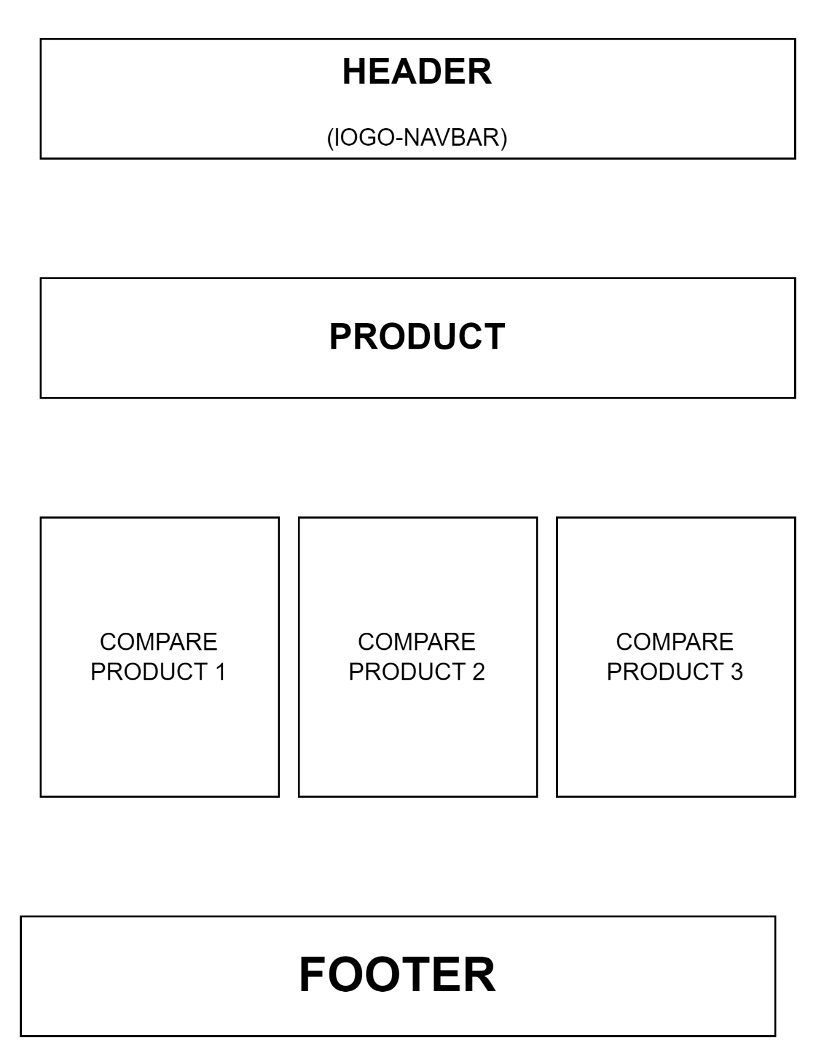

**4.About Us**

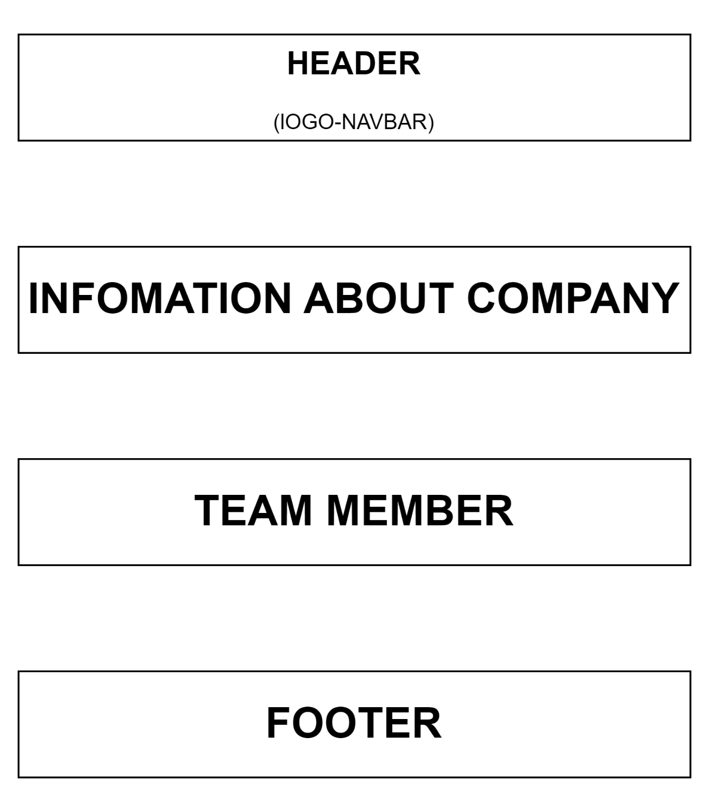

**5.Contact Us**

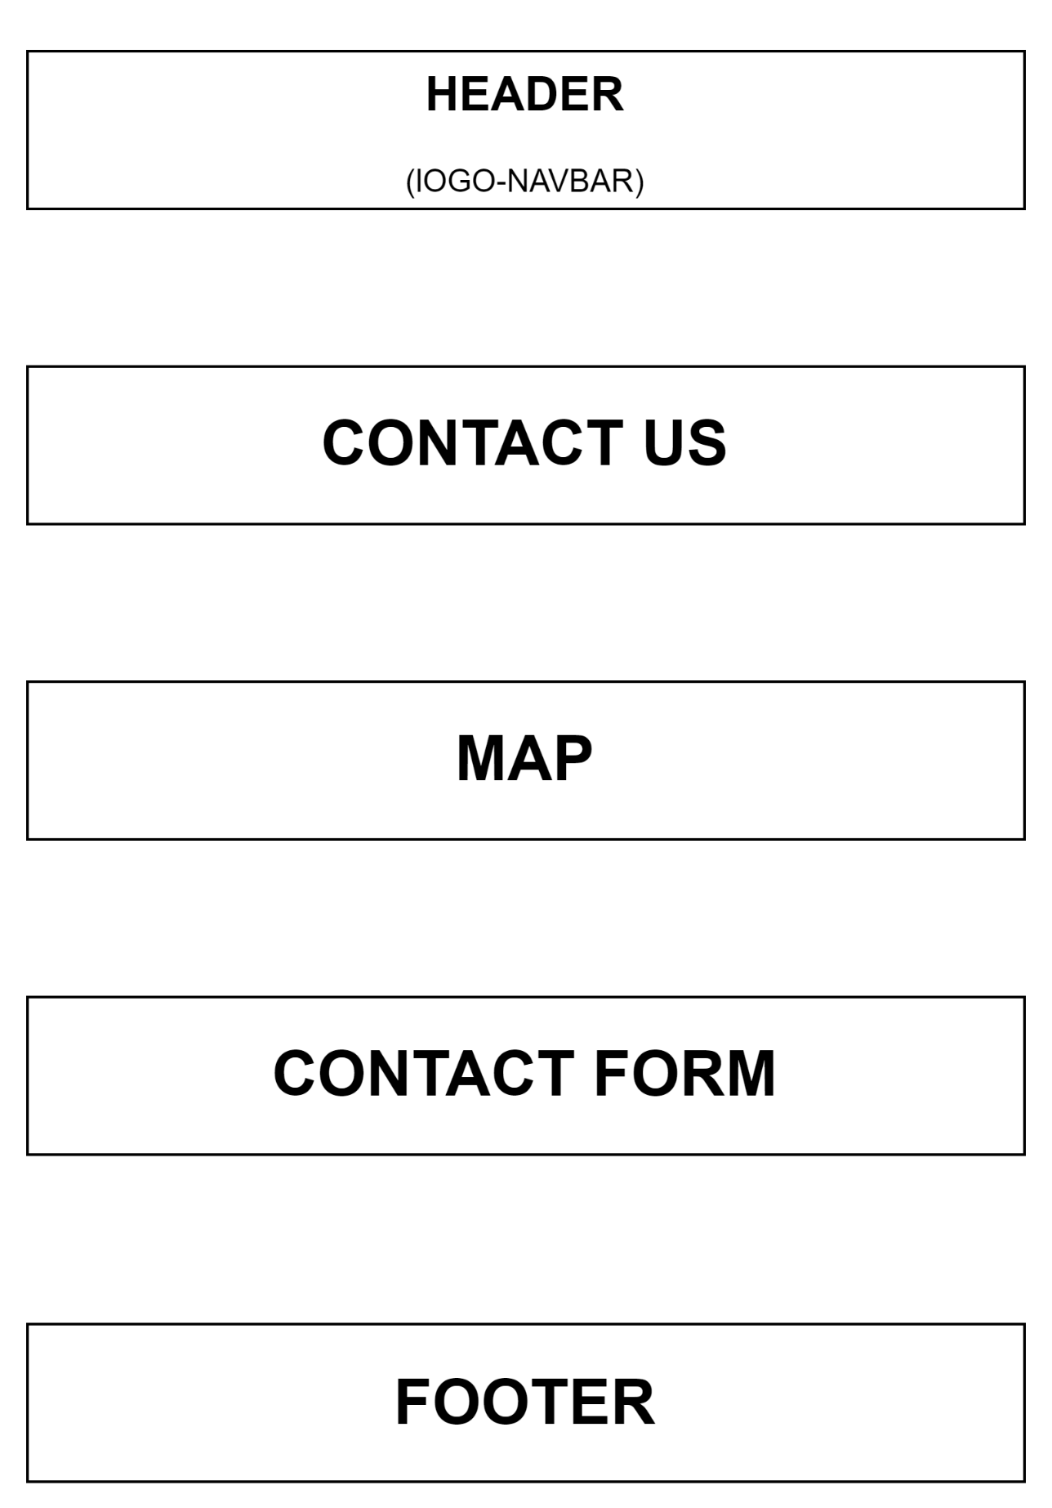

# TASK SHEET REVIEW 2

|  |  |  |  |  |  |  |  |
| --- | --- | --- | --- | --- | --- | --- | --- |
| **Project Ref. No.:**  **eProject/Advertisement Portal Management**  **System/01** | | **Project Title:** | **Activity Plan Prepared By:** | **Date of Preparation of Activity Plan:** | | | |
| **Sr.**  **No.** | **Task** | **Actual**  **Start**  **Date** | **Actual Days** | **Team**  **Mate Names** | **Status** |
| 1 | Site Map | HARVEL  ELECTRIC | The | 16-Nov-22 | 1 | The | Completed |
| 2 | Mock of the website | 16-Nov-22 | 2 | Quang | Completed |
| 3 | Task sheet | 16-Nov-22 | 2 | Hao | Completed |

|  |  |
| --- | --- |
| **Date:** | |
| Signature of Instructor:  **Ms. Le Mong Thuy** | Signature of Team Leader:  **Nguyen Van The** |

# WEBSITE DESCRIPTION

1. **Homepage**
2. Description

Home page displays following information:

- Slide show.

- Feature product.

- Some information about the website.

1. Screen shot

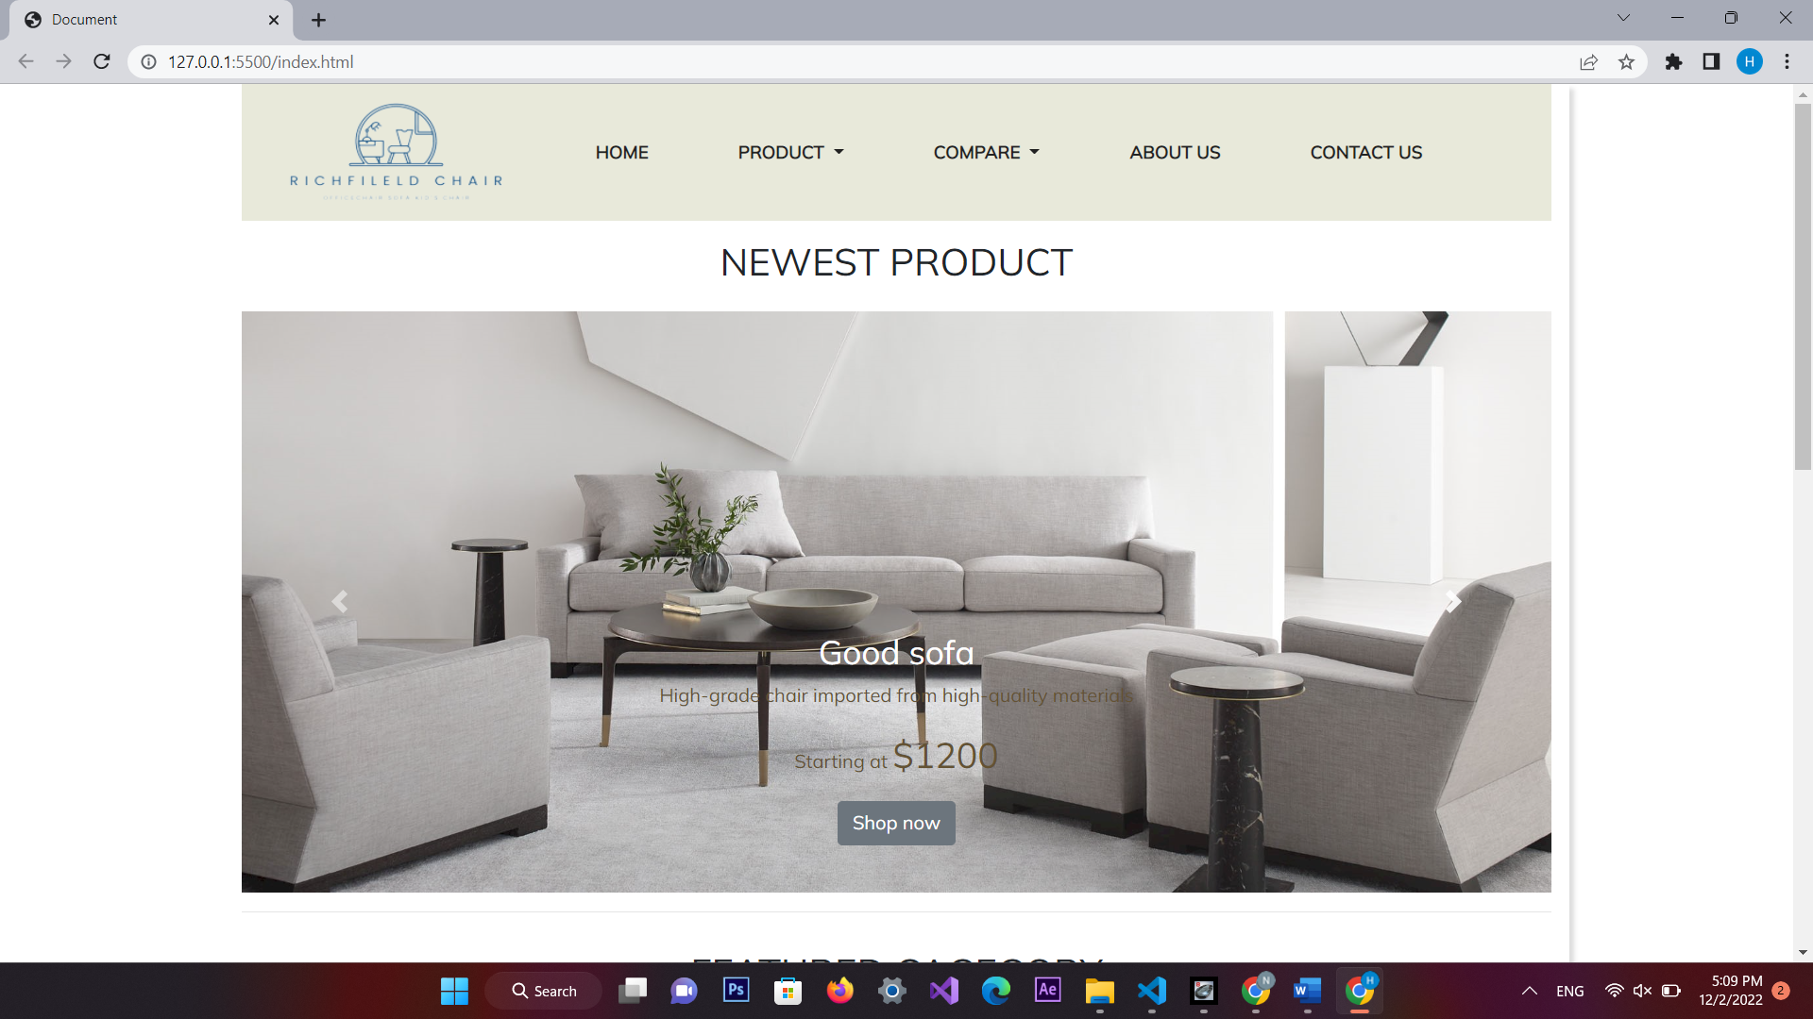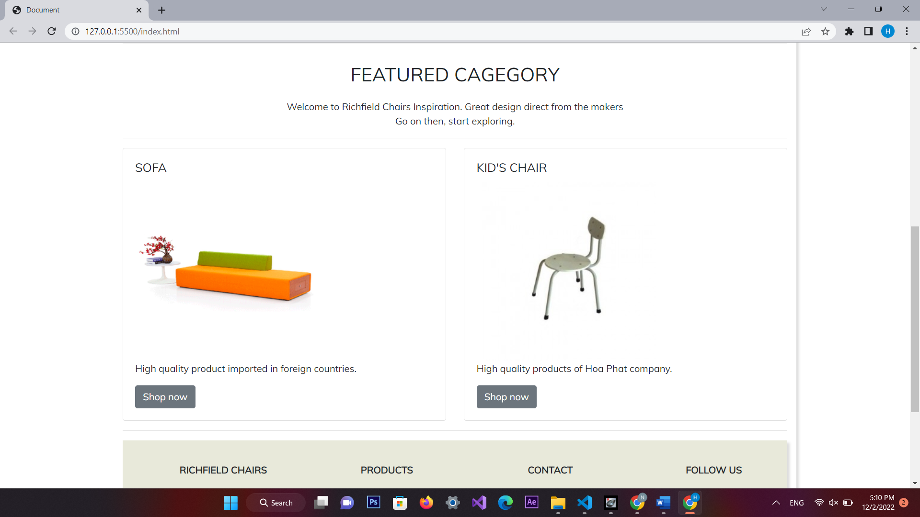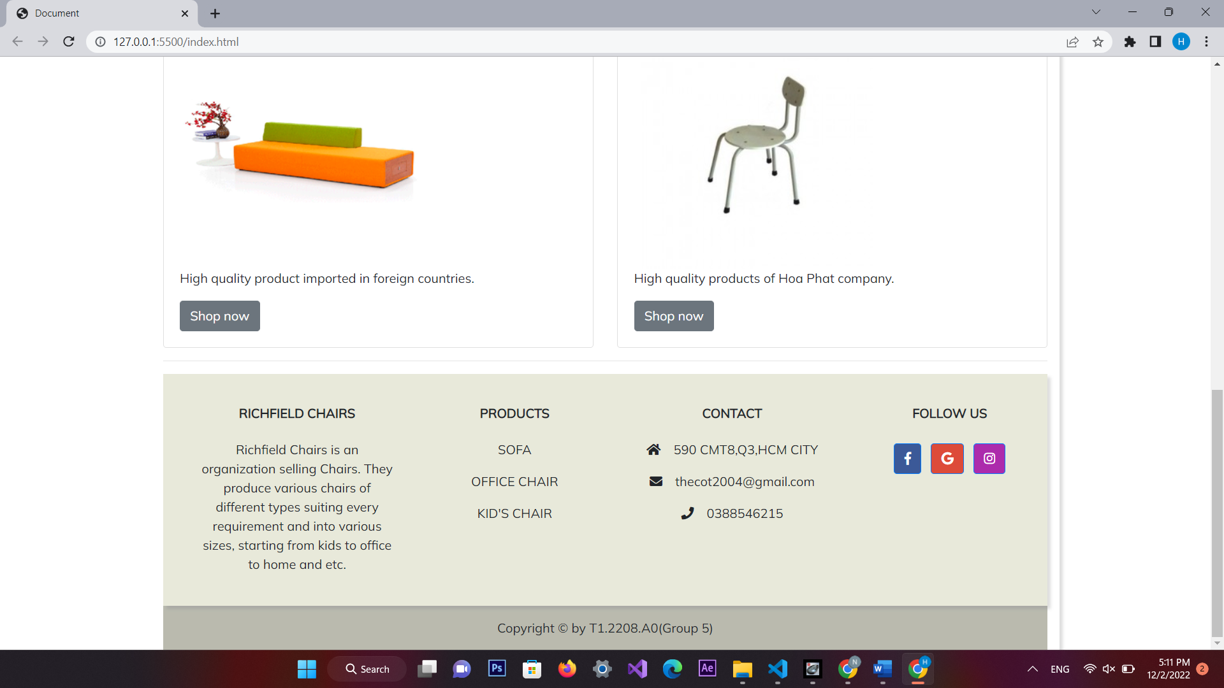

1. **Product**
2. a) Description This product page displays following information:
3. - All product that being sold at Richfieldchair when click on quick view item, it will show the detail of that item.
4. - Products can be compared with products of the same category
5. - Menu filter to easily find items based on categories.
6. - Product can sort by name
7. .Screen shot

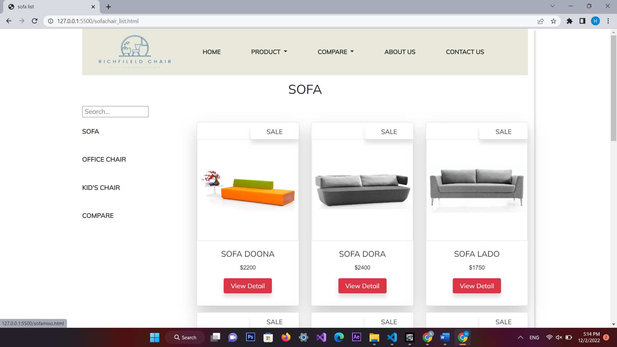 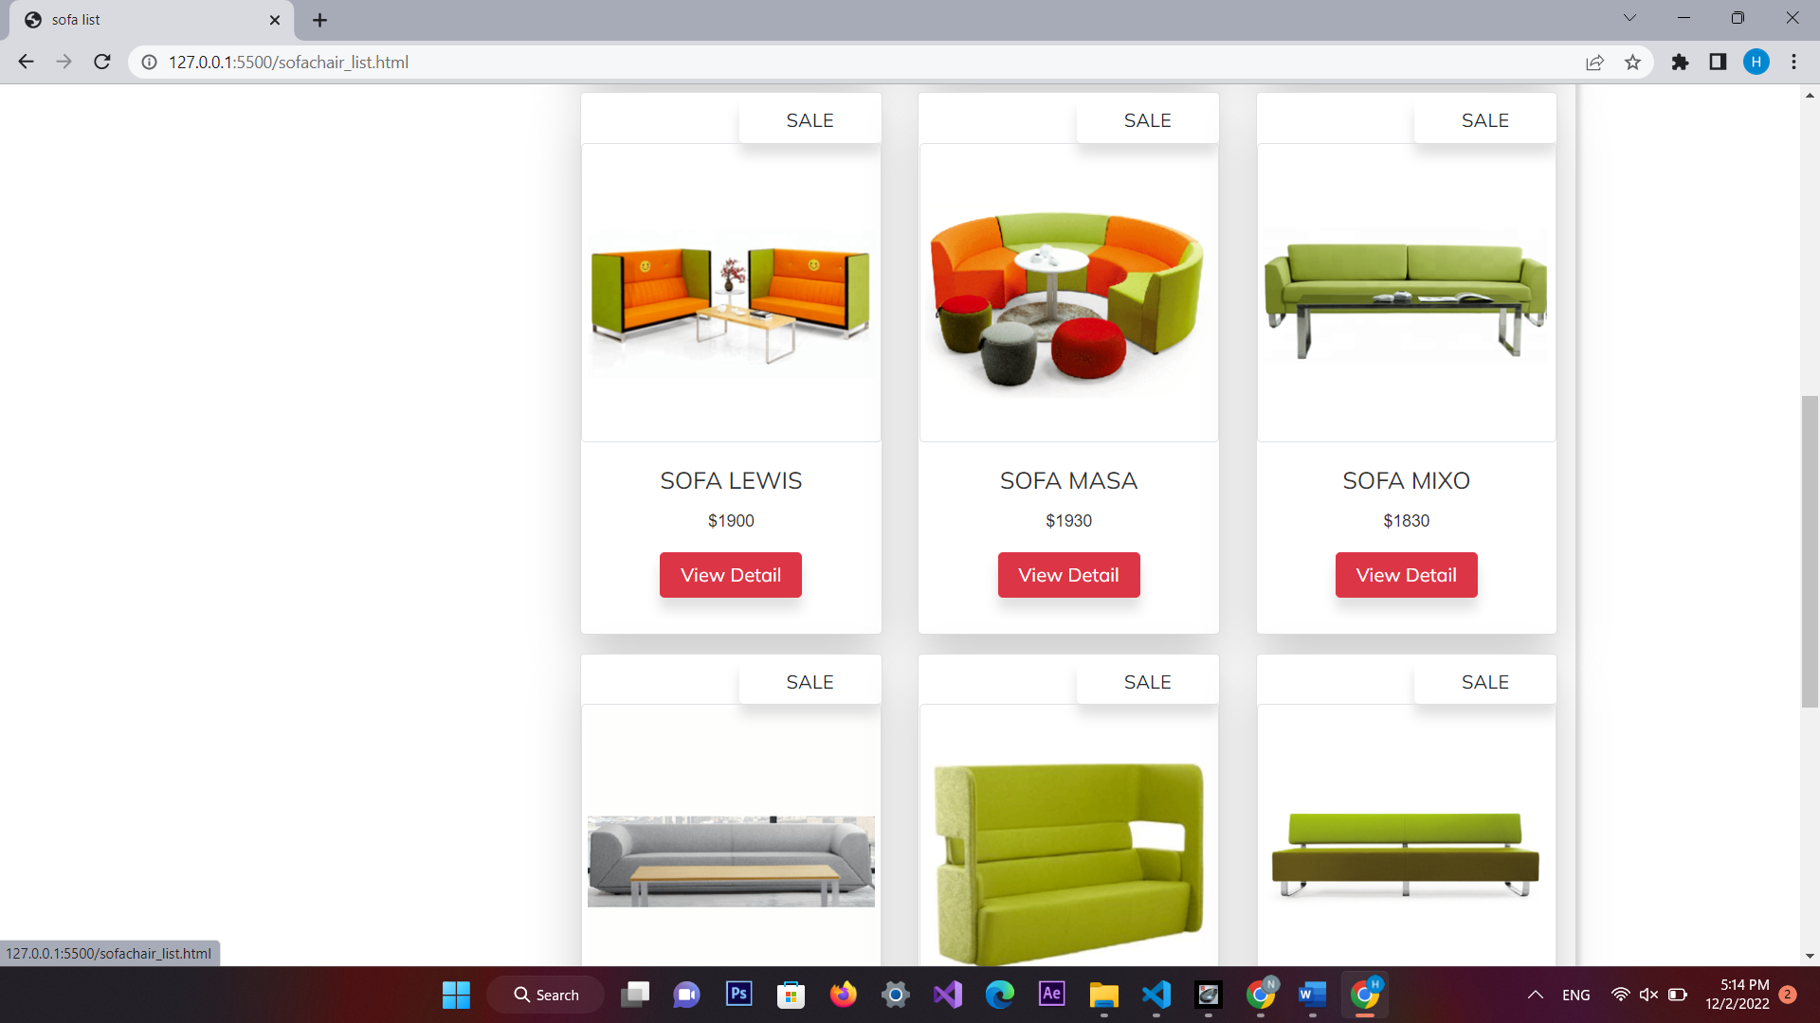 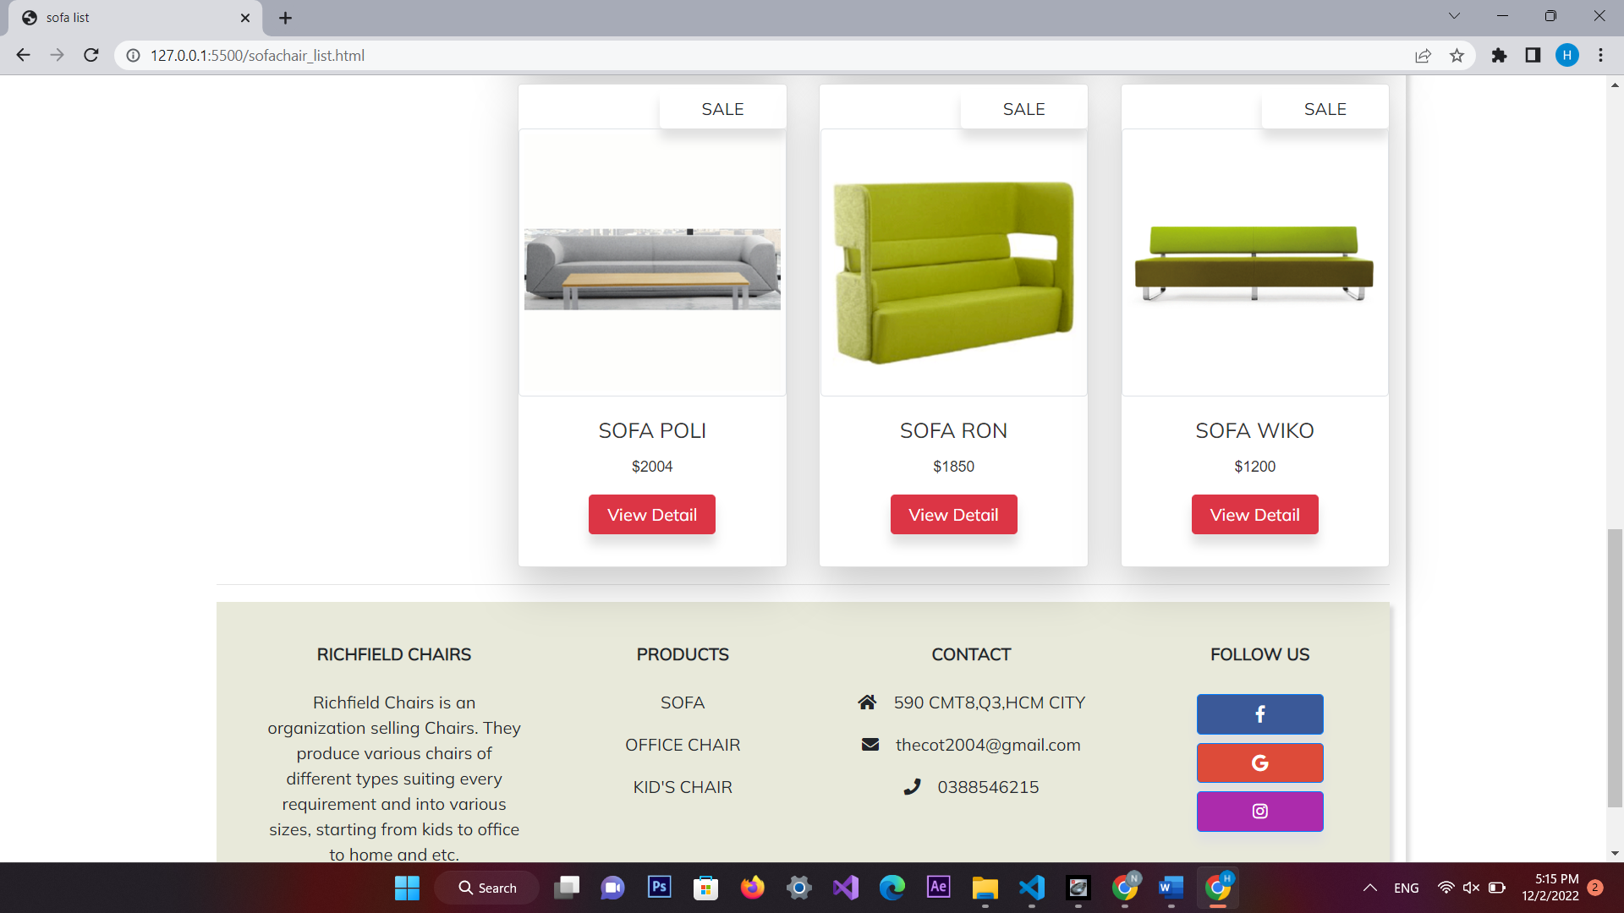 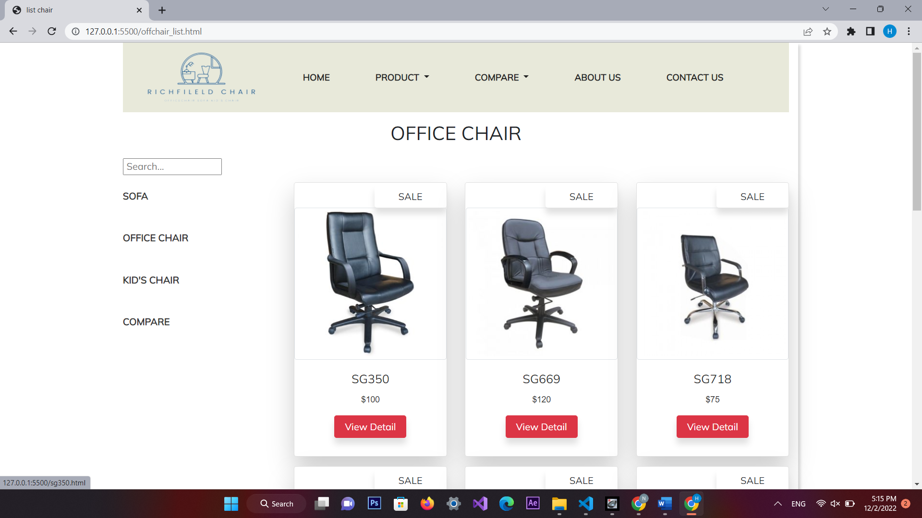 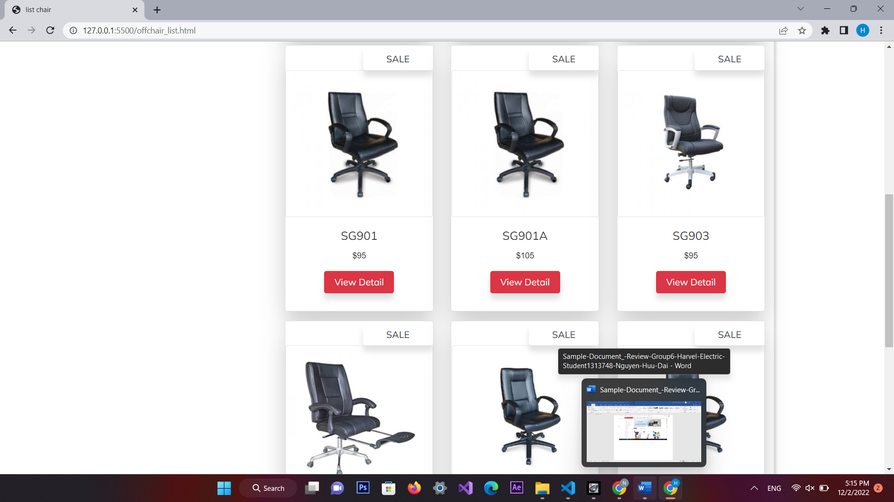 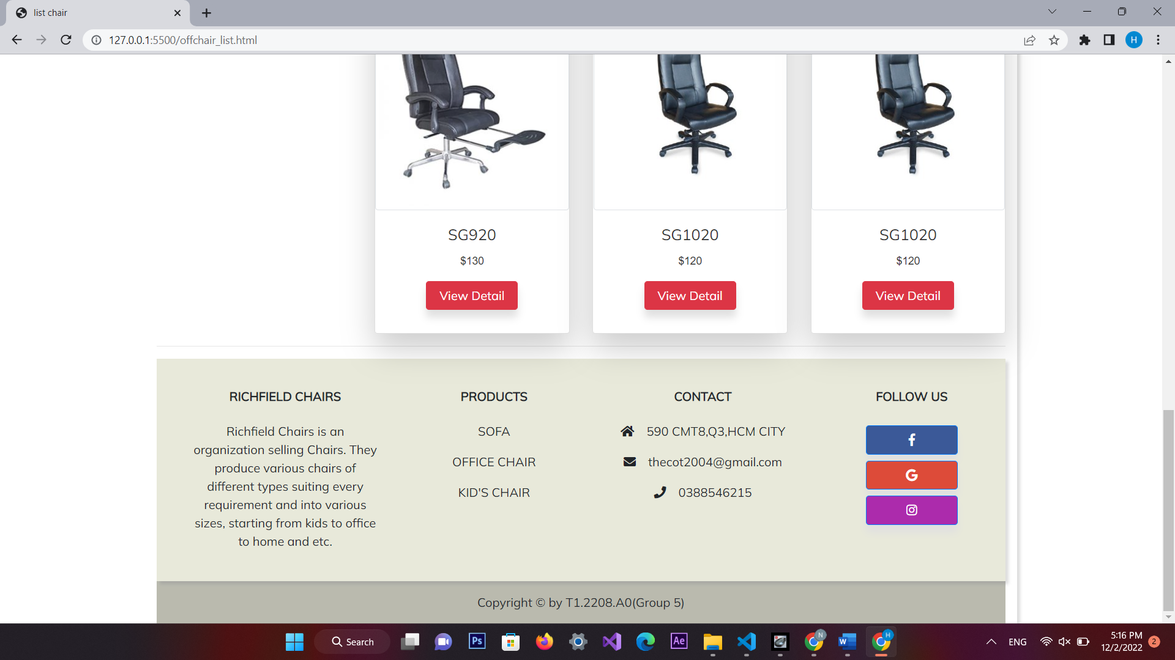 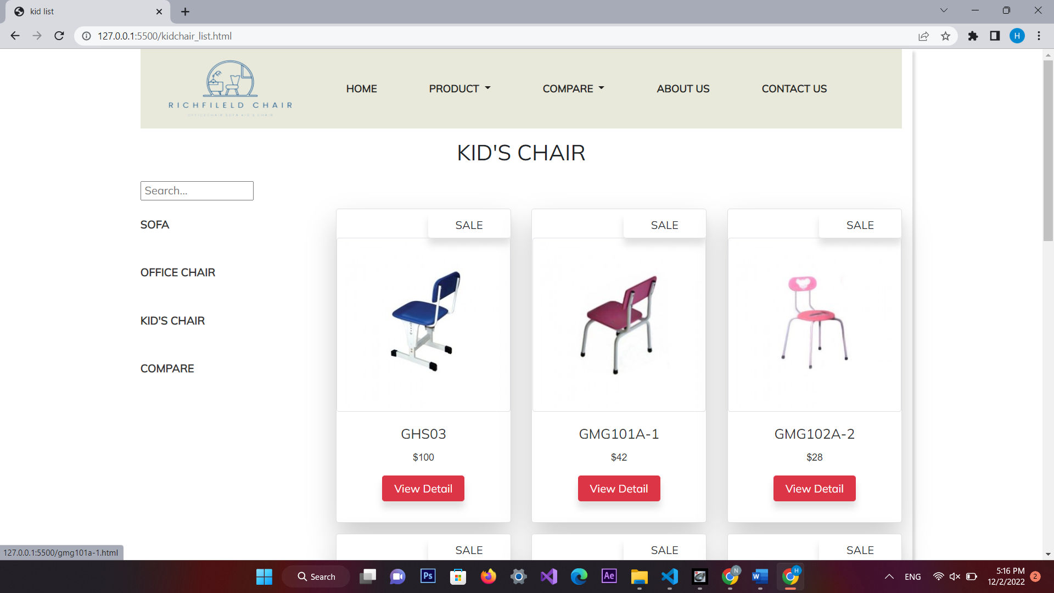 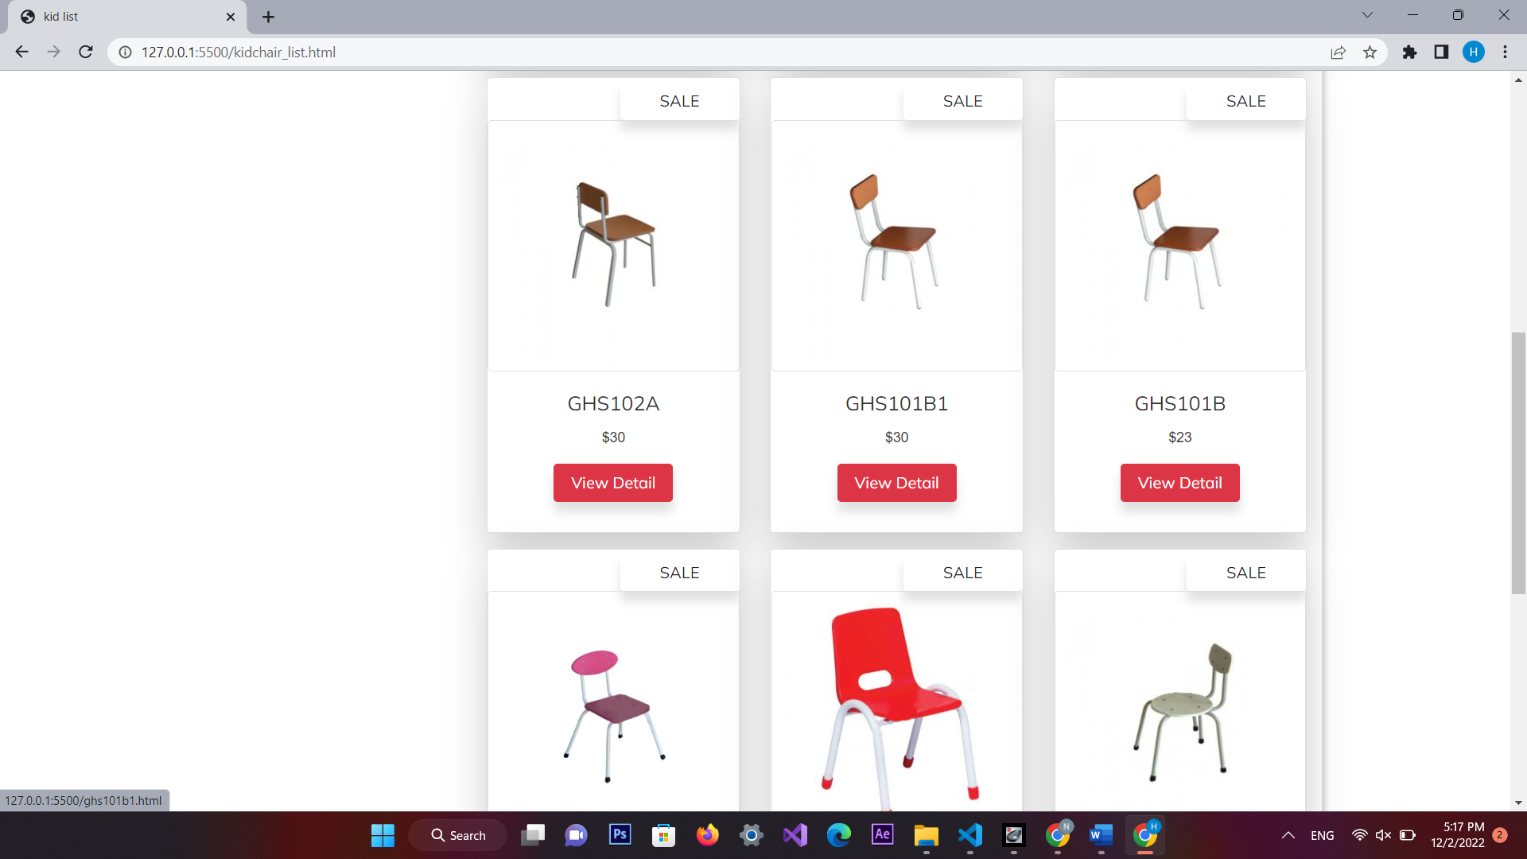 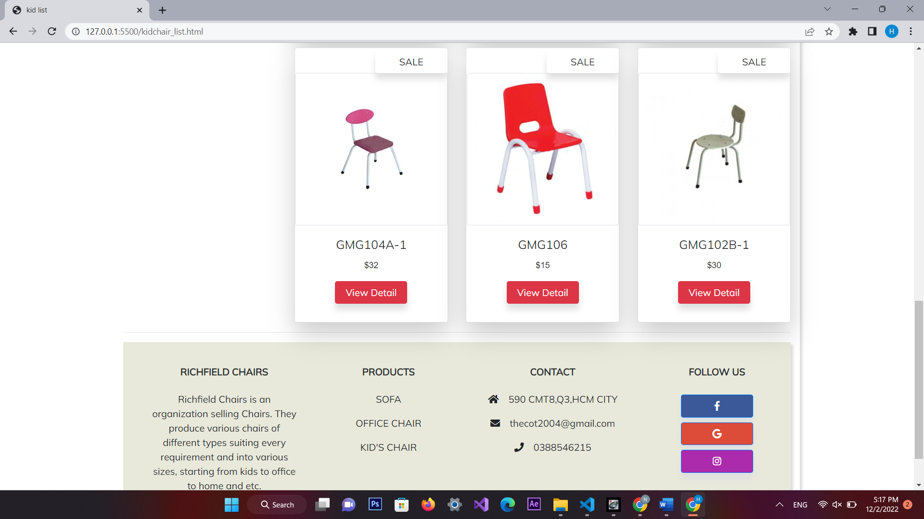

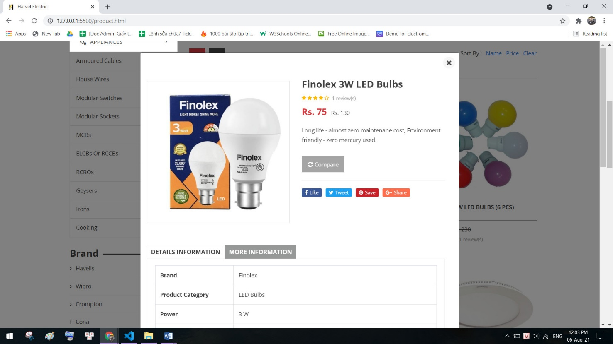

1. **Compare**
2. Description

The compare page displays following information:

- Infomation

- Compare

Screen shot

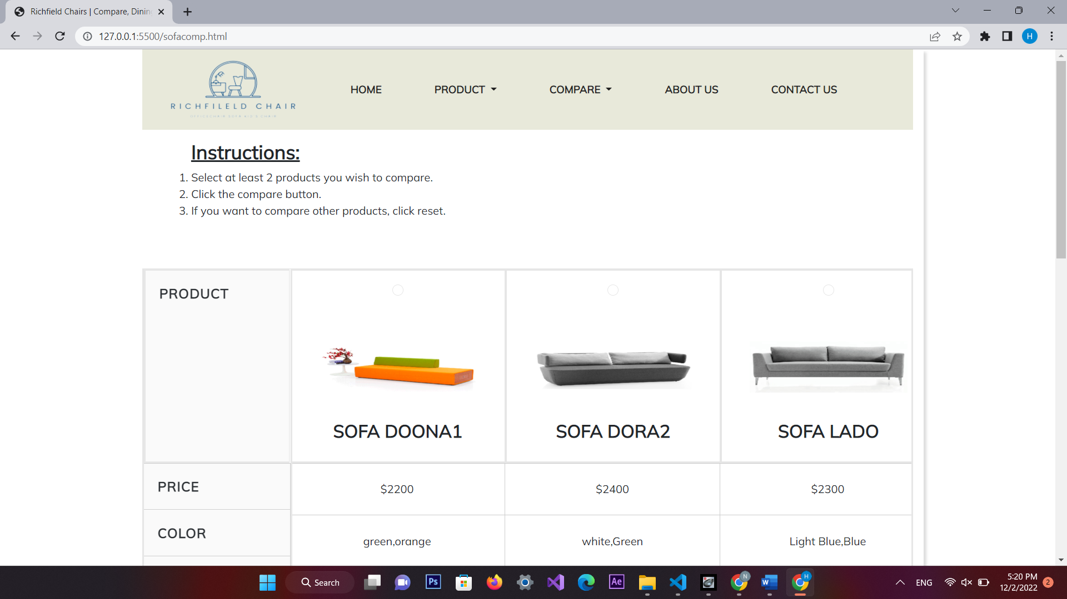 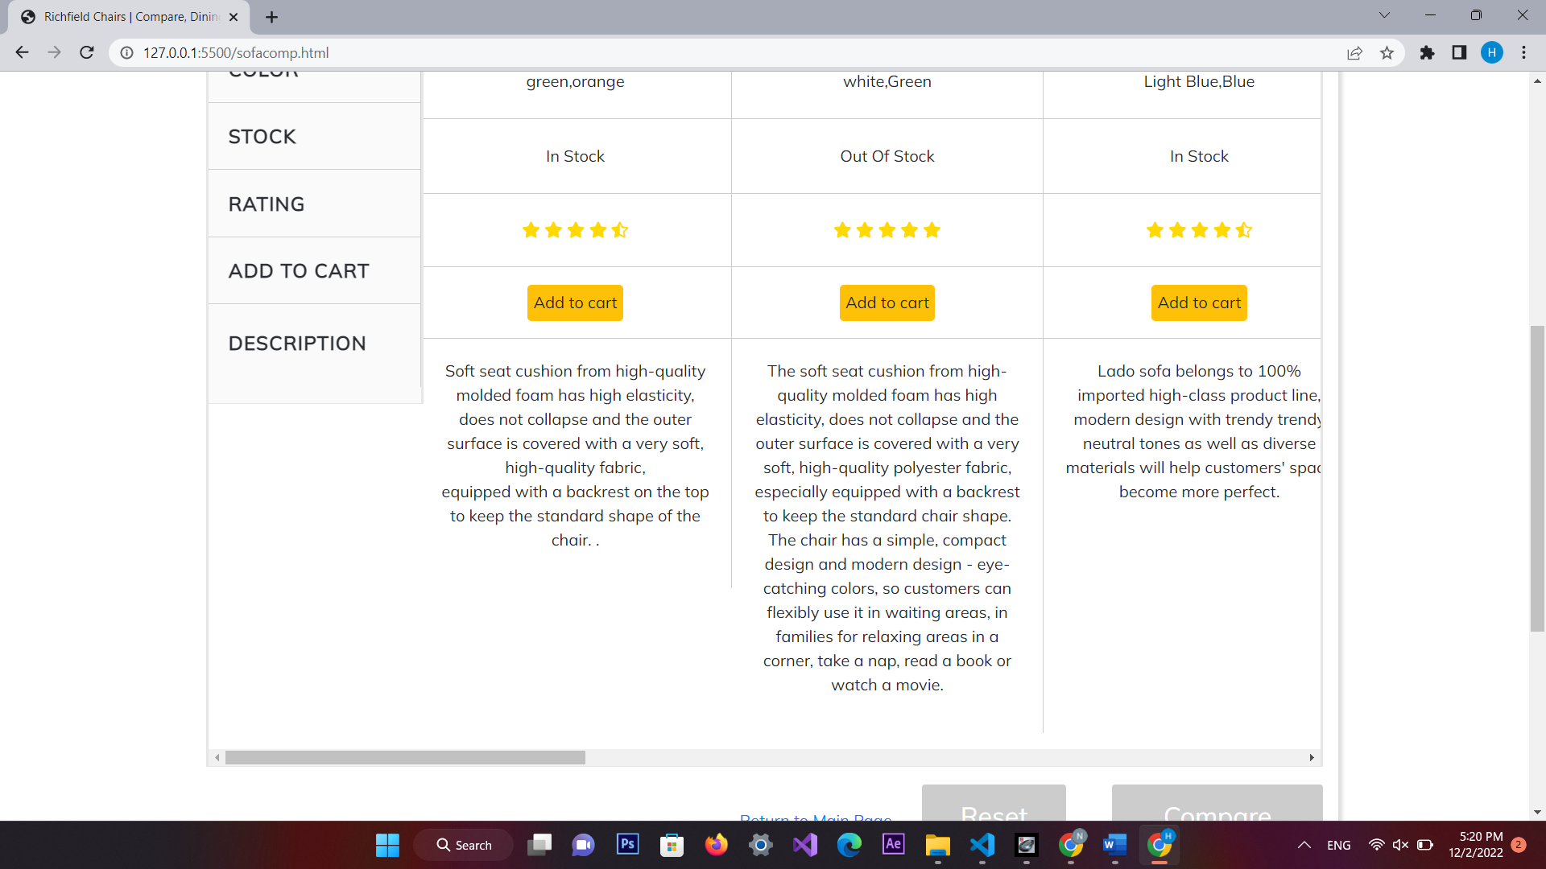 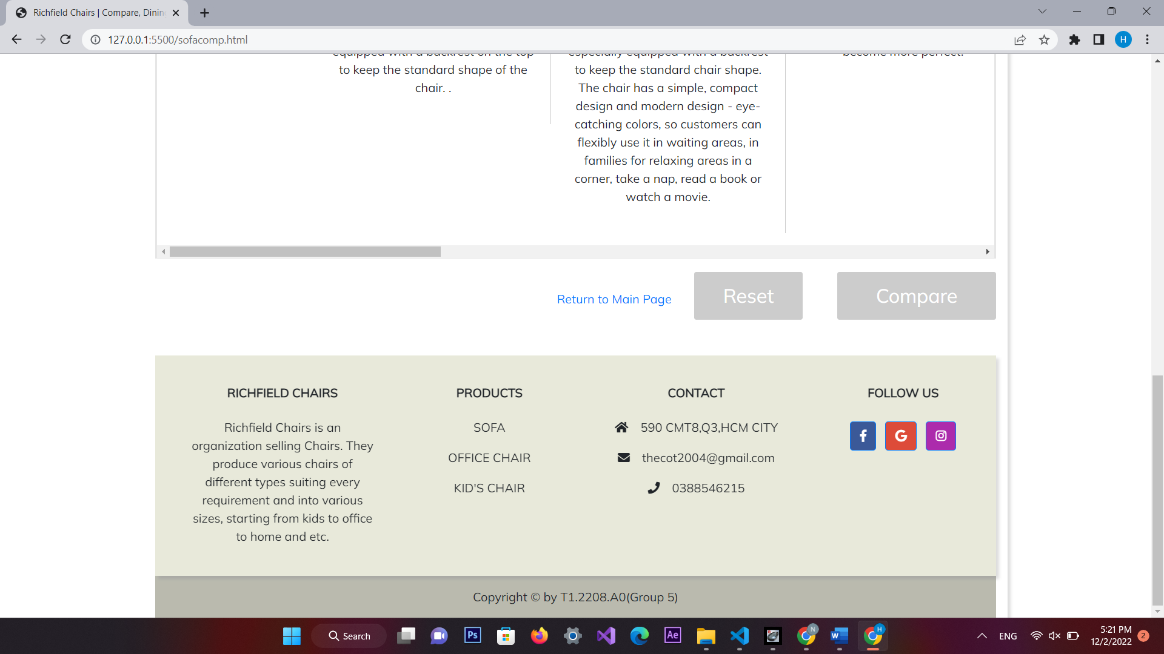 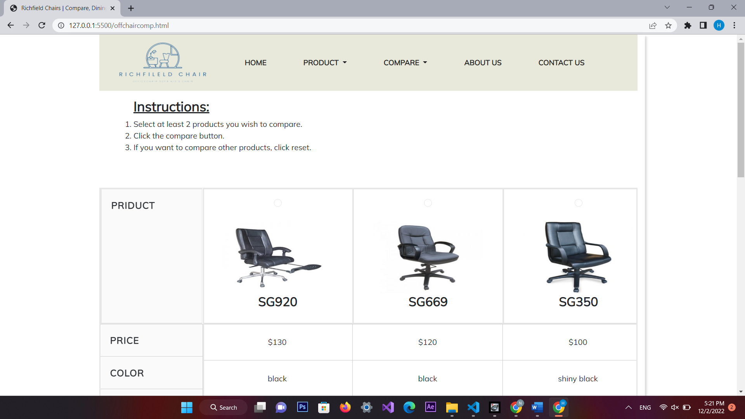 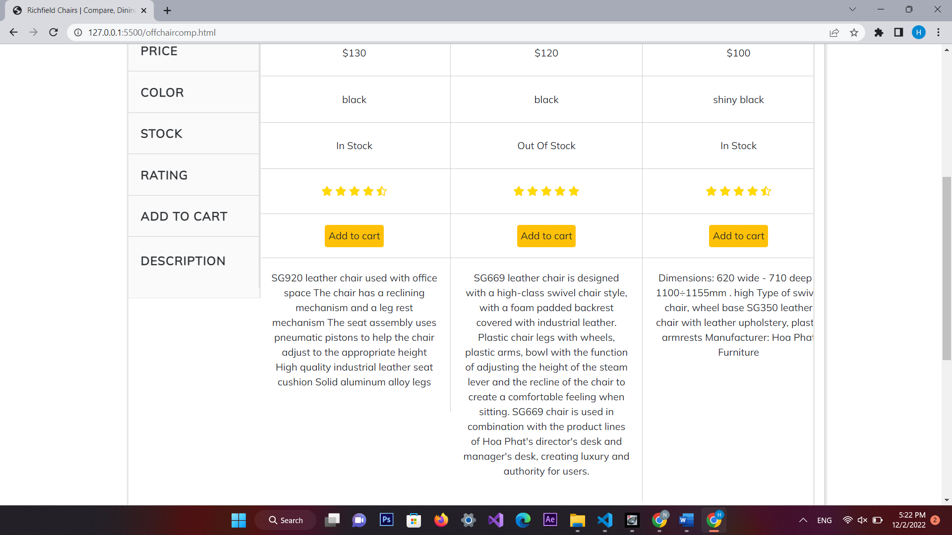 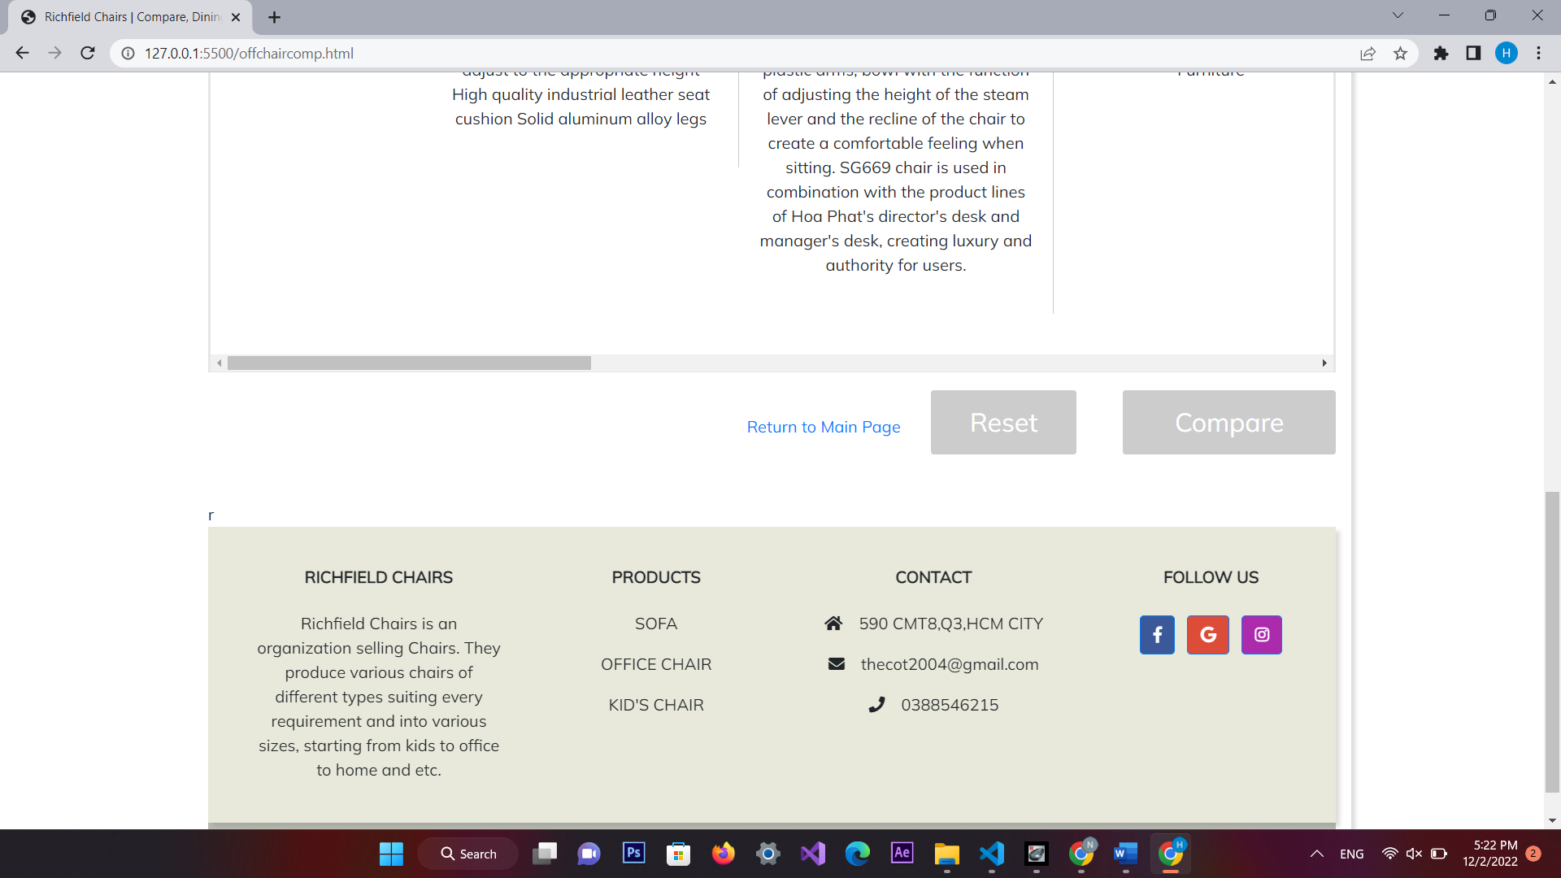 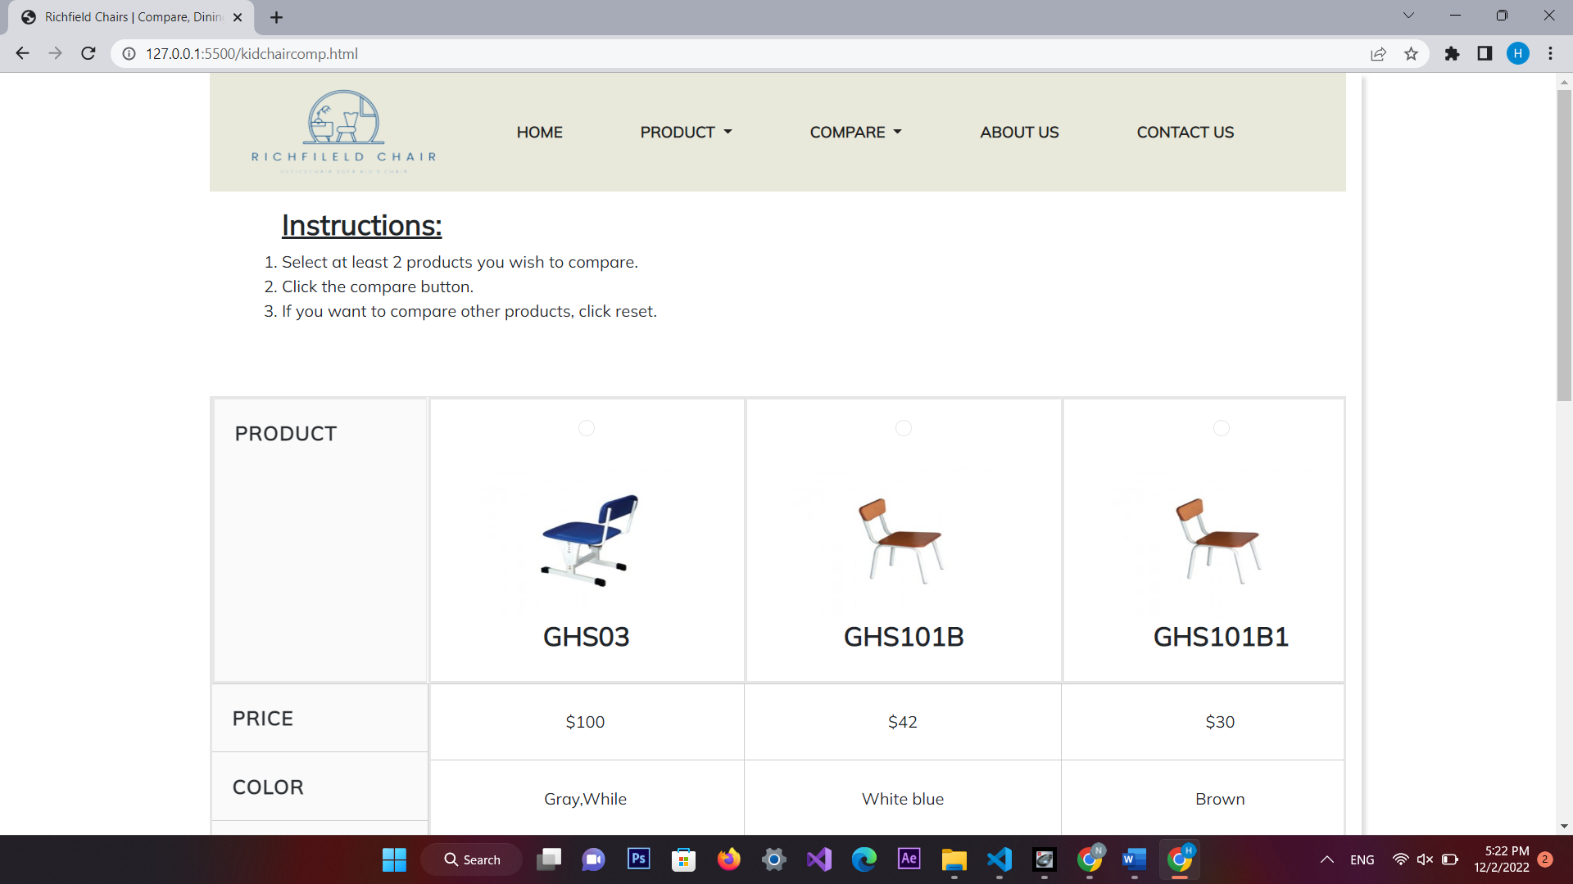 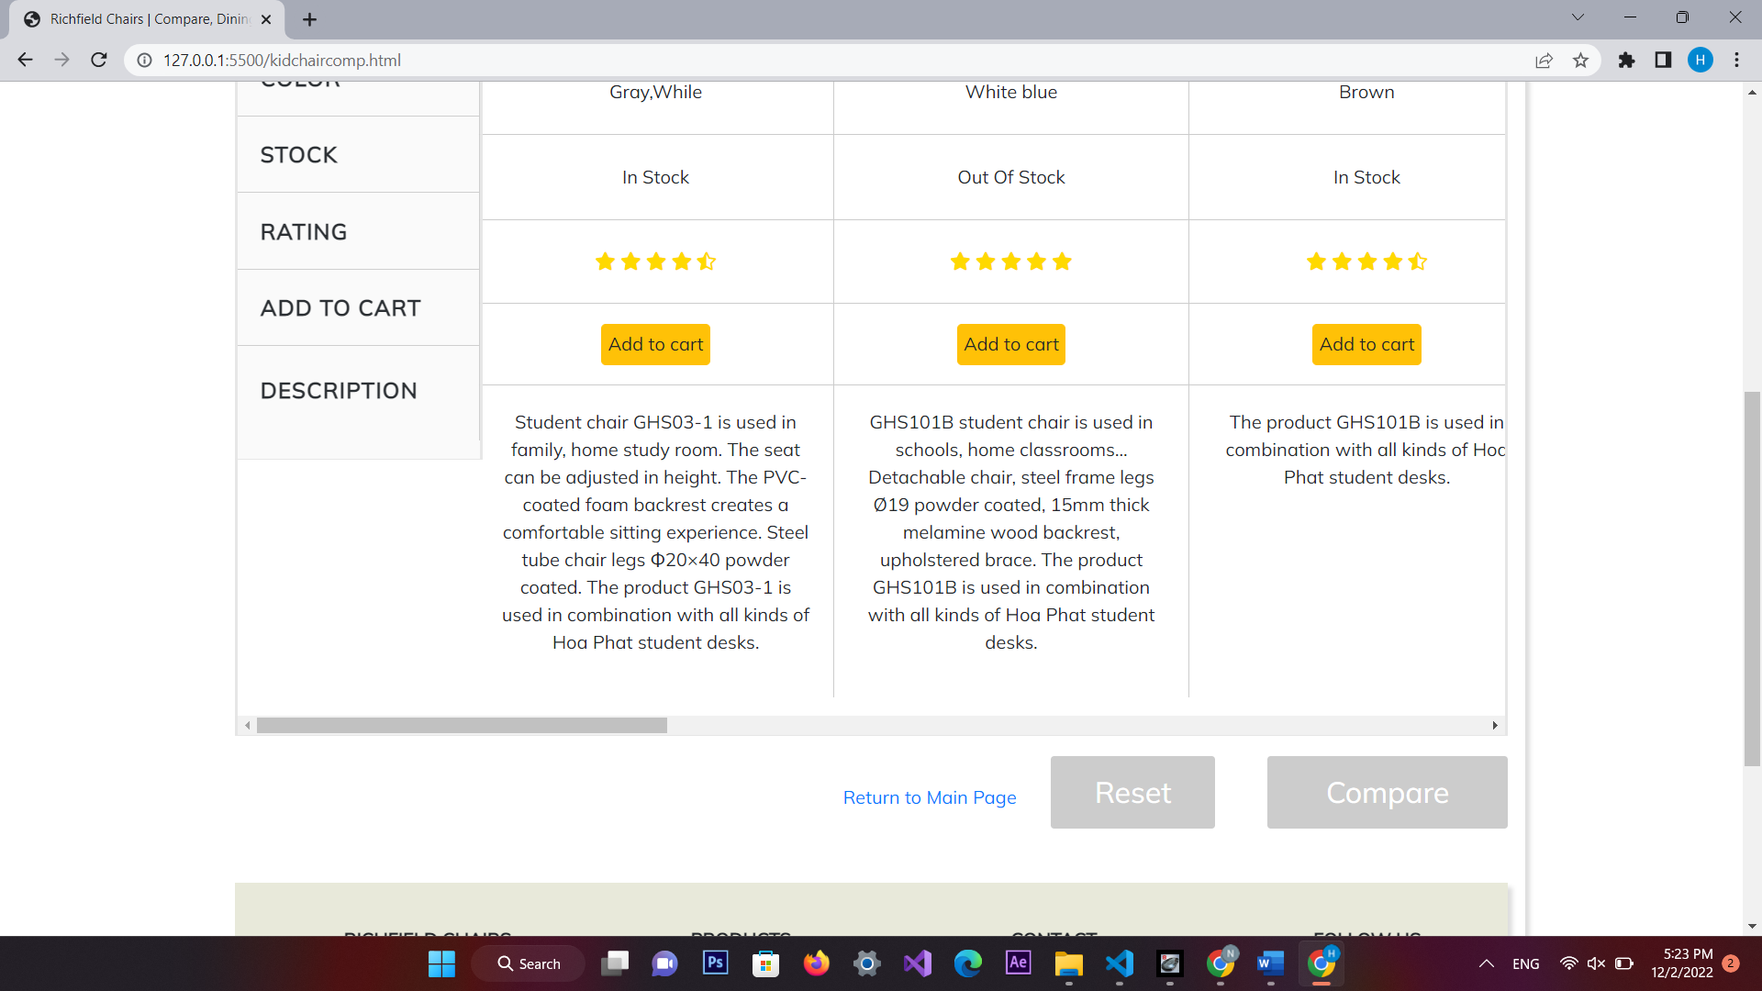 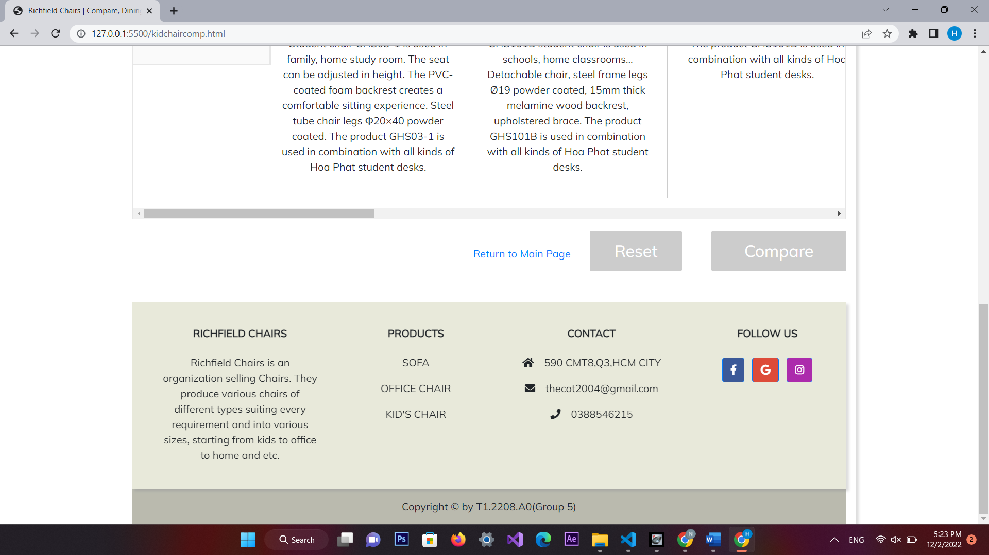

1. **About Us**

*Description*

This webpage display the information of the company, clients’ review and information about web creators.

*Screenshot*

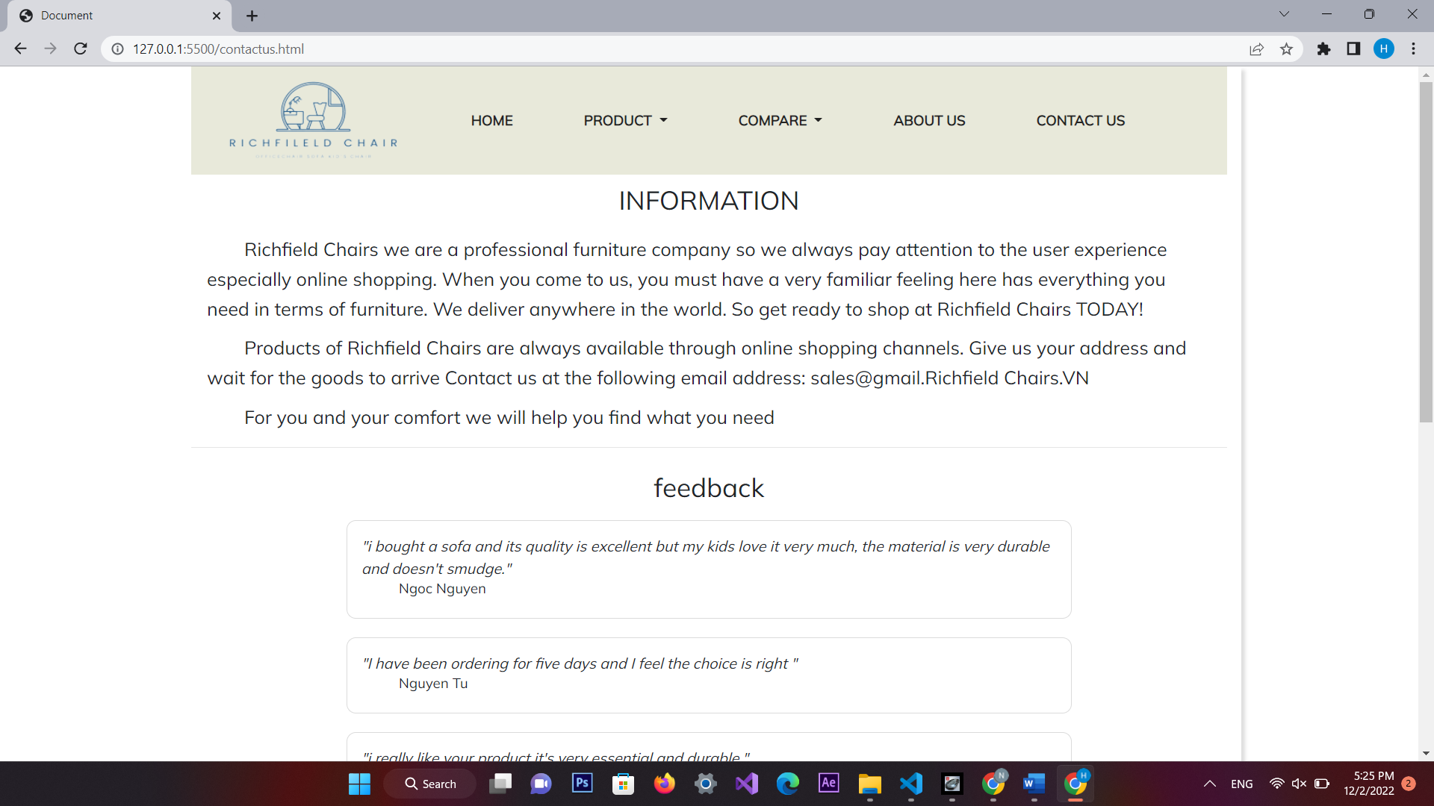 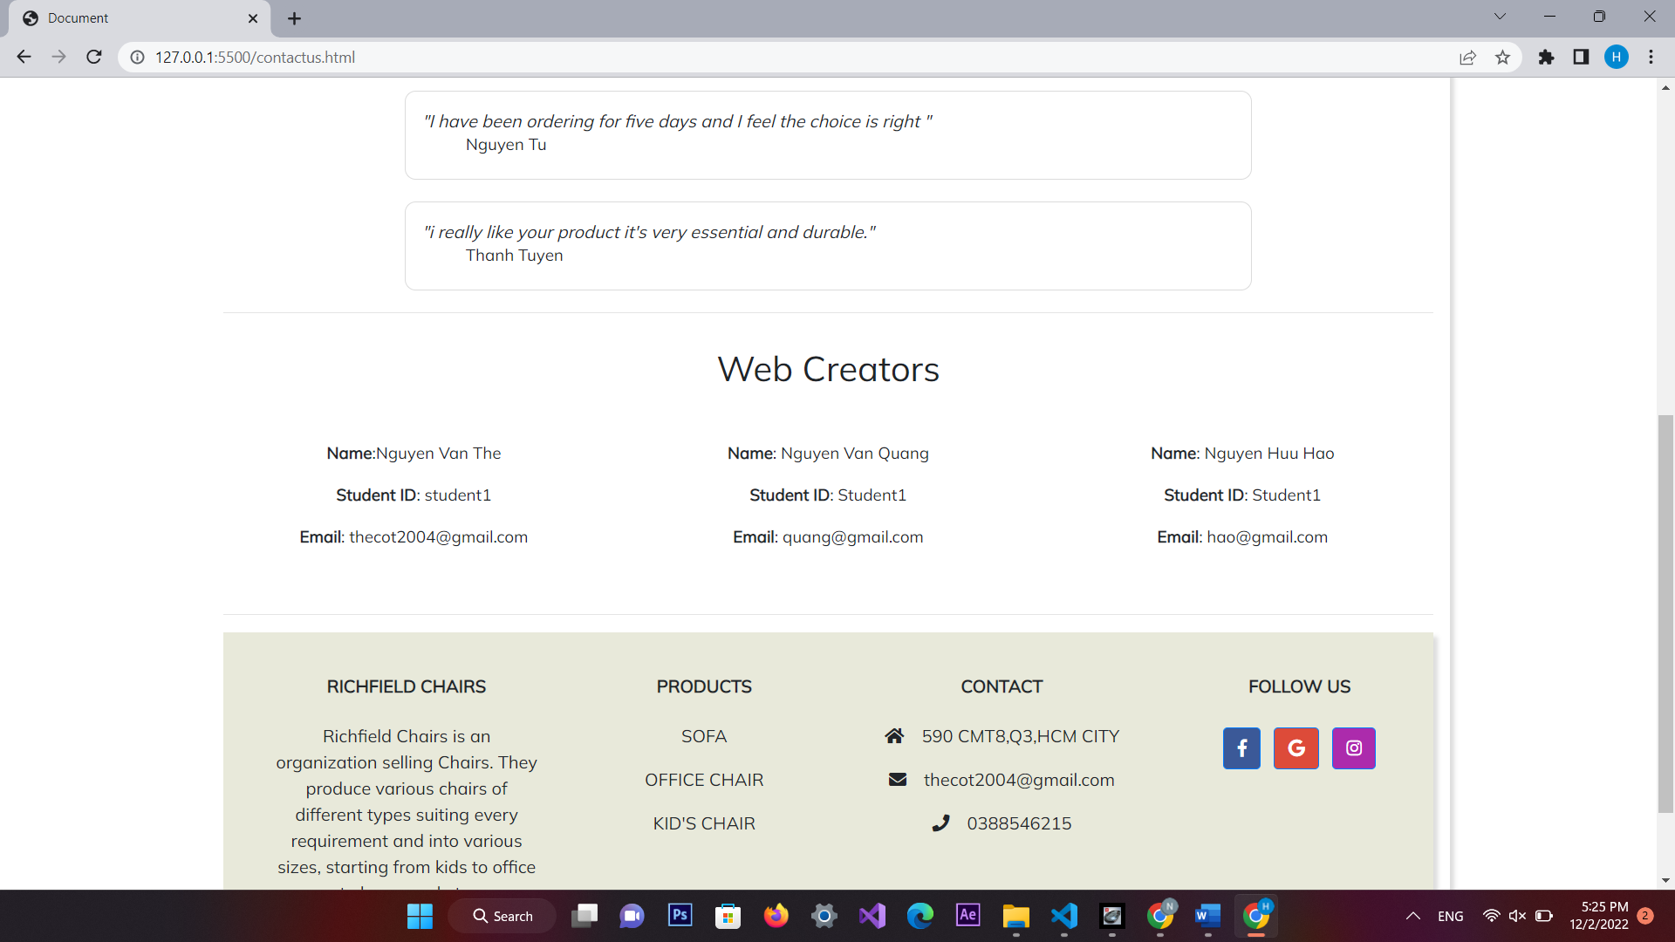

1. **Contact Us**
2. Description

This page displays contact information: location, telephone number, email and a quick contact form for customer

1. Screen shot

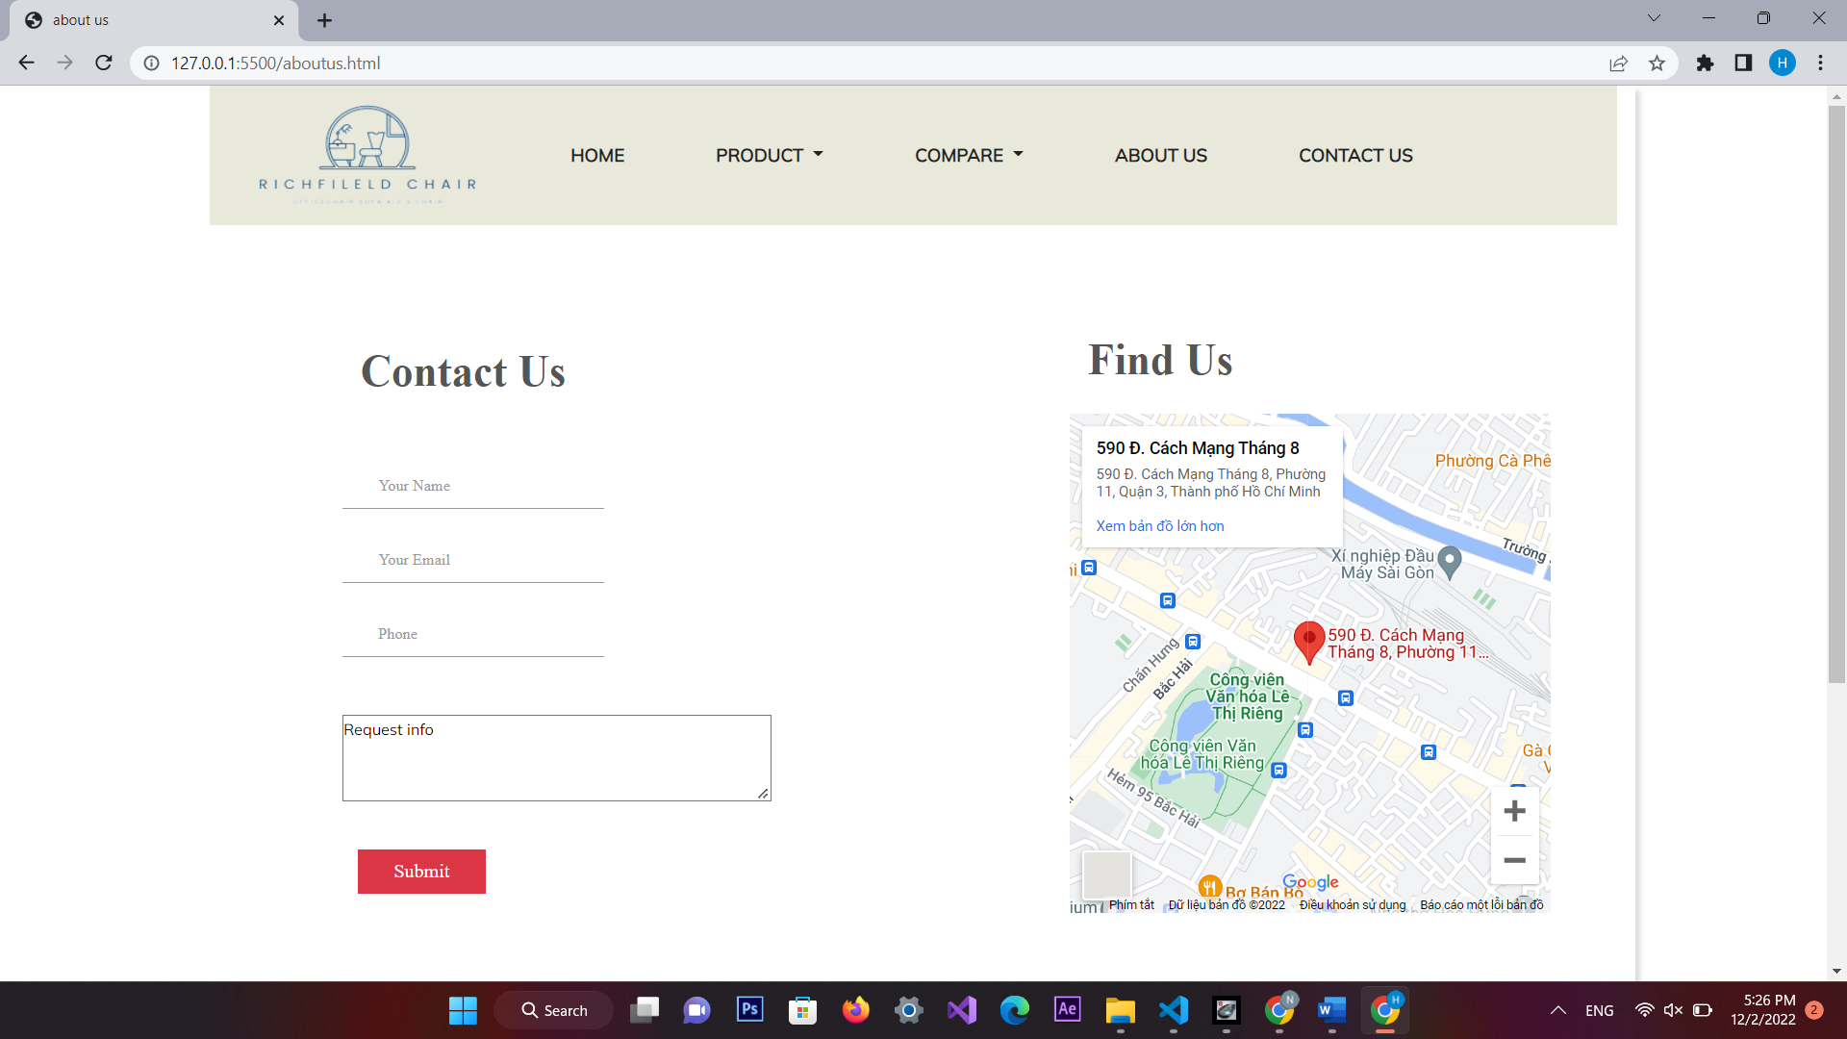 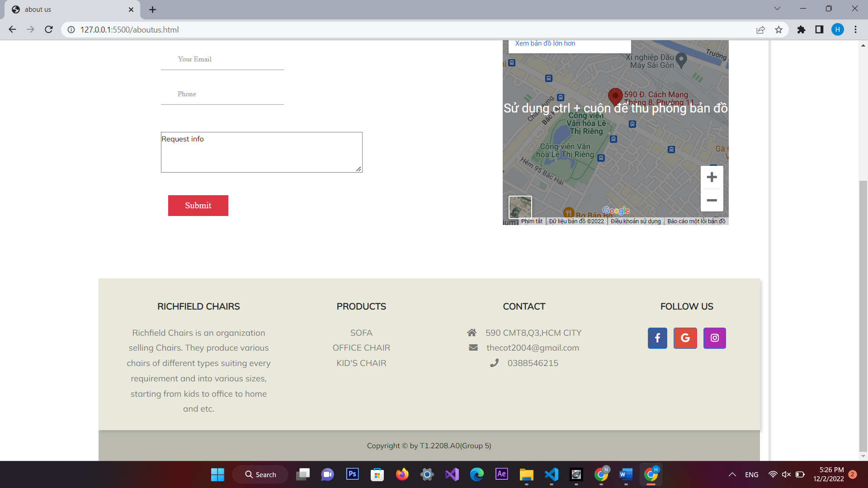

**RESPONSIVE**

The page has responsive feature for small screen device such as smart phone, tablet, etc.

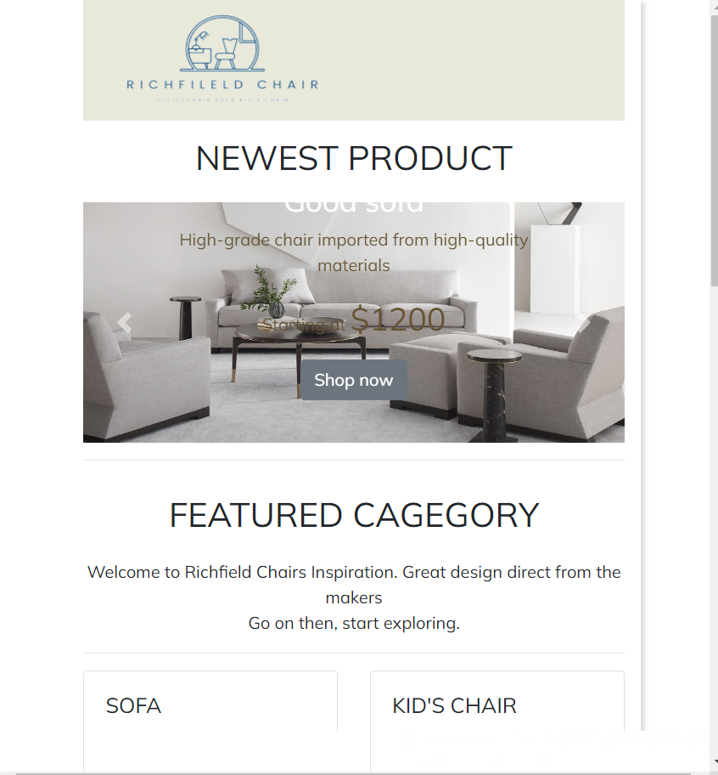

# JAVASCRIPT DESCRIPTION

This chapter will provide information about JavaScript function integrated in the website

### Zoom picture function

1. *Description*

This script is used for zooming pictures of product in detailed information pages. It is implemented with the support the Jquery library and elevateZoom library.

1. *Screenshot*

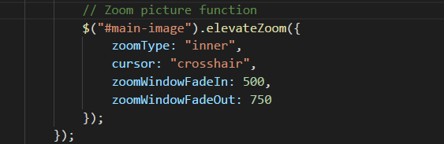

|  |  |  |  |  |  |  |  |
| --- | --- | --- | --- | --- | --- | --- | --- |
| ***Project Ref. No.:***  ***eP/Advertisement Portal Management System/01*** | | ***Project Title:*** | ***Activity Plan Prepared By:*** | ***Date of Preparation of Activity Plan:*** | | | |
| ***Sr.***  ***No.*** | ***Task*** | ***Actual Start***  ***Date*** | ***Actual Days*** | ***Team Mate***  ***Names*** | ***Status*** |
| *1* | *Home page* | *Richfield Chairs* | *Ngan* | 19-nov-22 | *1* | *The* | *Completed* |
| *2* | *Product* | 23-nov-22 | *3* | *The* | *Completed* |
| *3* | *Compare* | 25-nov-22 | *2* | *Hao* | *Completed* |
| *4* | *About Us* | 26-nov-22 | *1* | *Hao* | *Completed* |
| *5* | *Contact* | 28-nov-22 | *2* | *The* | *Completed* |
| *6* | *Sign in / Sign up* | 1-Dec-22 | *3* | *The* | *Completed* |
| *7* | *JavaScript Description* | 3-Dec-22 | *2* | *Quang* | *Completed* |
| *8* | *User Guide* | 4-Dec-22 | *1* | *Quang* | *Completed* |

# TASK SHEET REVIEW 3

|  |  |
| --- | --- |
| **Date:** | |
| Signature of Instructor:  **Ms. Le Mong Thuy** | Signature of Team Leader:  **Nguyen Van The** |